Ballot Usability Feedback – Port Chester Votes
Test conducted March 12, 2010 at Port Chester Village Hall
To: Port Chester Votes and FairVote
From: Whitney Quesenbery, with Michel Marut and Ron Cianfaglione

In this report
Summary – Overview of the test and most important results highlights 1
About the test – What we tested and who participated 2
Results – How successful participants were, and what confused them 6
Recommendations – What changes we suggest 10
Satisfaction – Results of the satisfaction questions at the end of the session 14
Detailed results - Details of the ballots used, tasks for participants and results 16

Summary
This document describes results of usability evaluation of ballot designs and instructions for voting for the June 15 Trustees election in Port Chester, NY. The usability tests collected feedback from people who are like typical voters on lever machine and absentee (paper) ballots as well as instructions for voting and voter education materials.
This usability test was conducted early in the planned voter education process: Port Chester Votes brochures had just been distributed through the local paper, and the first public education session had not yet been held.
The goal of this test was to gain insight into what aspects of the new election process are confusing, and therefore should be a focus of voter education efforts. It was also an opportunity to see how if any aspect of the brochure and ballot instructions were either particularly helpful or caused confusion.
Overall, participants generally succeeded in casting a ballot with 6 appropriately marked votes. Given the timing of this test, it is not surprising that there were some problems. The analysis of the results looked for patterns in the problems: were there specific aspects of cumulative voting which were confusing, and were there any issues that seemed to affect particular types of voters.
It is important to note that a usability test like this one is primarily a diagnostic tool. Although a usability test can provide quantitative data, this one was aimed at a more qualitative understanding. A usability test is necessarily an artificial environment. In this test, participants were given directions about how to vote and were voting on a ballot with names they had never seen before. This makes it a more challenging task than actually voting in an election. They also had to not only try to vote accurately, but vote to specific directions. (The directions, as presented to the participants, are listed in the detailed results section below along with images of the ballots.)
In this usability test, the analysis looked for the pattern or types of problems voters might encounter in the new cumulative voting system, rather than any sort of indication of the true quantitative magnitude of the problem.
The highlights of the results are:
- There is a strong indication of the need for clear, targeted voter education around the ability to vote more than once for a candidate under cumulative voting.
One cluster of participants consistently undervoted, by failing to add votes to their choices to make up the full 6 votes. There was no pattern to the ethnicity of the participants, or to which ballot they voted first.
- There is a strong indication that a piece of educational material specifically reminding voters about the rules for cumulative voting should be given to each voter at the polling place (or included with absentee ballots).
Two people undervoted on the lever machine, even though (as they put it) they knew they had six votes: the habit of voting once per candidate was stronger than their new knowledge.
- The voter education and ballot instructions need to stress the relationship of voting squares to number of votes.
Two people overvoted by filling in all of the squares under their desired candidates.
- Adding concrete examples showing how the different options translate onto a sample ballot would improve the instructional value of the voter educational material.
The Port Chester Votes brochure generally worked, but some participants pointed to the illustration of different numbers of checkmarks on figures, but still struggled to figure out how to apply the concepts in the images to the ballot they had to use.
- Voter education should include practice, to build confidence in knowledge and familiarity with the mechanics of cumulative voting.
One question on the satisfaction questionnaire showed a bias based on ethnicity: almost all of the Latinos agreed that they would need help; almost all of the whites disagreed.

About the tests
These evaluations were conducted on March 12 at the Port Chester Village Hall (in the Senior Center). The ballots and instructions were evaluated in individual interactive sessions with 18 people. Each person voted on 4 different ballots, following directions for which candidates to vote for. The ballots used colors for party names and realistic-but-not-real candidate names.
The purpose of these usability tests was to observe how easily and successfully voters could vote on ballots for the June 15 Trustees Election, using the instructions and other election information materials. This election will be the first use of cumulative voting and in which all trustees are elected at once.
We observed people who were eligible to vote doing so and noted what they did and said. We used sample ballots with made up party names (colors) and candidate names. We gave the participants instructions about how to vote.
We tried to answer these questions:
- Did they understand the basic concepts of cumulative voting?
- Did the instructions on the ballot help them understand how to vote accurately, whether or not they had seen voter education materials before entering the voting booth?
- Were they able to mark their ballot in a way that matched their intent?
Each session ran 15 to 20 minutes. We scheduled participants ahead of time, to ensure a demographic mix.

Who participated?
Port Chester, in Westchester, NY, is a small town of 28,000, with a population that is 46% Hispanic/Latino (of any race). The participants in the test were recruited to roughly match the Village’s demographics, with a mix of race/ethnicity, age and gender.
Race/Ethnicity  2 – Black/African-American  7 – Hispanic/Latino  (3 with low English proficiency)  8 – White  1 – Declined to answer | Gender  9 – Male  9 – Female | Age  2 – 20-29 years old  4 – 30-39 years old  3 – 40-49 years old  5 – 50-59 years old  1 – 60-69 years old  2 – 70-79 years old  1 – 80-89 years old
All but one of the participants are registered voters. All had voted most recently in either the November 2008 election or the 2009 Port Chester Mayoral election. The one first-time voter intended to vote in the June 15th election. All participants lived in ZIP code 10573.
The Hispanic/Latino participants had a range of levels of English proficiency. All opted to work without a translator, but many used the Spanish version of the instructions. Some asked if there was a Spanish translation on the ballot and directions and then pointed to it to show that they had found it. One participant asked an observer to help translate her comments and asked for a translation to clarify an instruction.
 | Personal Demographics |  |  |  | Voting Experience
# | Age | Race/  ethnicity | Gender | Physical limitations? | Regist-ered? | Voted before?** | Last voting system used
1 | 49 | Black | Female | No | Yes | Yes | Lever
2 | 74 | White | Female | No | Yes | Yes | Lever
3 | 52 | N/A | Male | No | Yes | Yes | Lever
4 | 40 | Latino | Female | No | Yes | Yes | Lever
5 | 60 | Latino | Male | No | Yes | Yes | Lever
6 | 82 | Black | Female | No | Yes | Yes | Lever
7 | 76 | White | Male | Yes* | Yes | Yes | Lever
8 | 42 | Latino | Male | No | Yes | Yes | Lever
9 | 39 | White | Female | No | Yes | Yes | Lever
10 | 34 | Latino | Male | No | Not sure | No | None
11 | 33 | Latino | Male | No | Yes | Yes | Lever
12 | 26 | White | Female | No | Yes | Yes | Lever
13 | 50 | Latino | Female | No | Yes | Yes | Lever
14 | 35 | White | Female | No | Yes | Yes | Lever
15 | 29 | Latino | Male | No | Yes | Yes | Lever
16 | 51 | White | Male | No | Yes | Yes | Touch screen
17 | 56 | White | Male | No | Yes | Yes | Lever
18 | 50 | White | Female | No | Yes | Yes | Lever
* P6: Answered yes to “Blindness, deafness or a severe vision or hearing impairment”
** Last election voted: 2008 presidential election-10, Port Chester mayoral election-7, None-1

What did we test?

Ballots and voting materials tested
We tested 4 ballots: 1 on the lever machine (Red), and 3 in the format of the paper absentee ballots (Green, Blue, Yellow). The ballots used neutral colors for party names, and realistic-but-not-real names from the NIST reference ballot for the candidates names. The arrangement of parties and candidates included fusion candidates (that is, candidates who appeared on more than one party line), as well as three candidates by petition.
The paper ballots were printed on legal (8.5” x 14”) paper, using the sample ballot Excel file provided by Port Chester. They were not optimized to fill the entire width of the page, or to use larger paper. The smallest font size was 10 points.
Participants were also given copies of the Port Chester Votes brochure explaining cumulative voting.
All materials were fully bilingual in Spanish and English. A translator was available to assist as needed.
Ballot images are in the section on results details at the end of this report, along with images of how participants marked the ballot.

Tasks
In this test, we gave the participants instructions about how to vote. We wanted to create situations in which they had to engage in moderate problem-solving to match their intent to the ballot, including fusion candidates and ensuring that they completed their ballot accurately.
The order in which participants used each of the ballots was randomized, so each ballot was tried 1st, 2nd, 3rd and 4th by roughly a third of the participants.
The details of the tasks and specific ballot layouts are in the section on detailed results, at the end of this report. Directions for how to vote on each ballot were given on paper, in both Spanish and English. Moderators did not read the tasks out loud. If participants asked questions about how to vote, they were referred to the ballot and voter educational materials for information.

Test Staff
Whitney Quesenbery and Michele Marut moderated the sessions. Ron Cianfaglione acted as note-taker.
Mrs. Doris Bailey-Reavis, a long-time Port Chester poll worker, ran the reception desk, greeting participants and having them complete the consent form and demographic questionnaire.
Rob Richie and Elias Baez also observed sessions and took notes.
Martha Lopez arranged for the test participants. Village Clerk Joan Mancuso and Elias Baez ensured that the voting equipment was ready for the test.

Results

How successfully did participants vote?
Participants were generally successful in casting 6 votes on each ballot. In most cases, they also successfully followed the directions given to them for how to vote.
Of the 72 opportunities to vote:
34 ballots were completed successfully
22 ballots had undervotes
6 ballots had overvotes
- All of the overvotes were cast by the same two people. In all cases, they filled in all of the squares for each of the candidates they wanted to vote for.
- Most of the undervote errors were in voting just once for each candidate named and not casting any additional votes to complete the ballot.

What did participants find confusing or difficult?

General issues
Many of the participants made comments about how confusing or overwhelming they found both ballot styles. The paper ballots were more confusing to some, because they are unfamiliar. “It was confusing to have to look across the line to find people.” (P2) Those who found the lever machine more confusing talked about the number of names on the ballot (that is, candidates X 6). Some of the participants used their hands to guide their vision across the long rows and columns.
As one participant put it after realizing that she had made a mistake in casting her ballot on the lever machine “Change is difficult for many people. [We will] need hand holding and help…just I like I blew my 4 votes.” On all of the ballots, participants had questions and hesitations about how the new cumulative voting worked. One said that he “would walk out not sure if he had voted correctly, but thought he had the hand of it.”
The voting directions for the tasks were deliberately a little difficult, so that participants would not mark random choices; the specificity of the instructions meant that they had to think carefully, and problem solve to cast their ballot.
Most participants attempted to follow the directions, but a few had their own ideas and stuck to them. In most cases, this affected how they cast their discretionary votes (those not in the directions) or how they apportioned their votes. For one, however, this meant finding Spanish-sounding names on the ballot and voting for them (successfully casting 6 votes), regardless of directions.

General issues around cumulative voting
Although many of the participants successfully cast 6 votes on each ballot, following the directions, there were some patterns of errors that reveal misunderstandings about how cumulative voting works, despite having read voter education materials and ballot instructions.
- The undervote pattern shows that one group of participants did not understand the basic premise: 6 votes, and the ability to vote more than once for a single candidate. 5 participants cast undervotes by voting once for each candidate, but not completing their 6 votes on all (or all-but-one) of the ballots.
- For a few participants, undervoting mistakes made on their first ballot were corrected on all others. In two cases, the undervote was on the lever machine, a voting system where they thought they knew how to vote and did not, therefore, read the instructions.
- Two participants completely misunderstood how to use the paper ballot, and filled in all of the voting squares for their (correctly selected) candidates.
Two participants wrote in names to complete their ballot.
- One did so in a way that seems likely to be counted correctly (both writing in the name and filling in the square), but duplicating a name already on the ballot.
- One, however, seemed to misunderstand how write-ins worked. With directions that she supported a specific party, she wrote names from another party line in blank squares, but did not create a square to fill in. It is not clear whether the election canvas would count these votes or not. (She also undervoted, by only voting once for each of the names.)
Some participants worried about the mechanics of their votes:
- On the paper ballots, several people asked if it mattered which voting square they used.
- On the lever machines, they seemed more confident, and chose levers in an apparently random pattern. Some, more experienced voters, did not know if they could vote more than once per row and experimented to find out.

Issues with the instruction wording and voter education materials
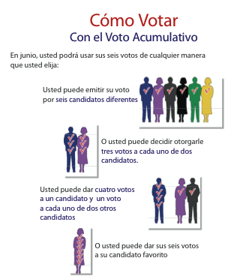
Many of the participants said they had seen the Port Chester Votes brochure before – it was included in the local paper in the same week as the testing.
At least two people pointed out the page showing different ways they could distribute their 6 votes as one that they found useful and informative. However, they also reported that they had trouble translating this explanation into how they would actually vote. They wanted to see specific illustrations of what each of the patterns would look like on the voting machine. The illustration of the lever machine shows how to move the lever, but not how to combine votes for a single candidate.
Many of the participants read the ballot instructions carefully. None had questions about the instructions, and felt that they were “not difficult to understand.” Despite this,
- There was a large group of undervoted ballots because the participants did not use all 6 of their votes. Of 72 (18 participants x 4 ballots) ballots cast, 21 had undervotes in a pattern that indicated that the participants did not understand that they should cast all 6 of their votes.
- Two participants did not understand how to mark a single vote for a candidate, and instead filled in all 6 of the squares for each candidate, creating an overvote.

Issues on the lever machines
The most common error on the lever machines was casting just 1 vote for the two candidates named in the directions, and not casting the other 4 possible votes. The 4 participants who made this error said that they “forgot” – carried along by the habit of voting just once per person.
One value of the lever machines is that they prevent overvotes, by limiting the number of levers that could be flipped.
- Some participants were not sure if they had to carefully select only one lever on each row. They experimented with different levers to find out.
- Some participants found the levers stiff, especially at the bottom and right side of the machine face. This made it difficult to tell if they were allowed to vote with that lever (at all, or within their 6-vote limit).
The biggest challenge in using the lever machines was the difficulty in reading the names under each lever. The lighting is not good inside the booths (even with the curtain open as it was for the usability test), and the black-on-color printing made the problem worse.
Very few people read the instructions at the top of the machine. This was a combination of the awkward reading angle, and that these experienced voters assumed they already knew how to use the system.

Issues on the paper ballots
About half of the participants took the time to read the instructions on the paper ballot, even if they did not do so on the (more familiar) lever machines. There was no strong correlation between whether they did so and their success in casting a ballot both according to the directions and with 6 valid votes. This seems to confirm a strong need for not only training, but opportunities for instructed practice.
Several people used a check mark in the box instead of filling in the square completely, as shown in the directions.
Participants showed no particular pattern in which square they filled in. They started from the upper left, upper right, and selected a box somewhat randomly. One participant asked if it mattered.
Many of the participants were very careful in how they filled in the squares. One participant suggested that a “dabber” – a large felt-tip pen of the kind used for games – would be helpful to those who could not hold a pen securely. Another participant said that she thought the squares were small for people who might have trouble with dexterity.

What changes do we suggest?
For the lever machines
- Use the party colors on the top strip with the party name, but print the candidate names in black on white for the greatest contrast.
- Keep the extra columns between the parties helped the participants “read” the ballot (if possible, based on final numbers and configuration of candidates).
- Ensure that the levers have been maintained so that all are equally easy to use to vote. This is especially important for levers on the bottom row, and at the right side of the machine face, which get little use in other elections.
- Be sure that there is as good lighting as possible within the voting booth with the curtain drawn, to make the names as easy to read as possible.
For the paper ballots
- When the ballots are printed, be sure that the text size and the size of the voting squares is as large as possible (on the prototype ballots tested, the ballot was only 6.25” wide).
- Make the voting squares as large as possible within the layout to make it easier for people with dexterity issues to mark them. Use as wide spacing as possible between them to avoid accidental overvotes.
Enhancements to the ballot instructions
There are several specific enhancements to the ballot instructions that would help voters who might make one of the two primary errors we saw during this test (not using all 6 votes and marking all six boxes for each candidate selected on the paper ballot). If these changes cannot be made to the ballot instructions for the June 15 election, voter education materials, including both pre-election and at-the-polls materials should stress these points.
- On the lever machines: Simplify the voting instructions by removing the sentence that says “Vote for none, one, two, three, four, five, or six candidates.” It is redundant with the next sentence that says “You have a total of six votes.” If this sentence is legally necessary, replace it with “Vote for up to 6 candidates.” (The research team that tested ballot instructions for NIST confirmed that it is better to spell out the numbers, but also said that the shorter format was more successful in their research.)
- On the paper ballots: re-arrange the voting instructions so that the information about cumulative voting comes with the general voting instructions. Add a line to explain that each square represents one vote. Drop the line “Vote for one, two…” (see note about this above).
PORT CHESTER BOARD OF TRUSTEES
Six (6) at-large positions open for 2 years- 9 month terms

Voting Instructions:
To vote, fill in a square above a candidates name, like this: ⬛
You have a total of 6 votes.
- Each square represents 1 vote.
- You can cast your 6 votes in any combination.
- You can vote up to 6 times for one candidate.
- Do not cast more than 6 votes.

Use blue or black ink.
To vote for a person whose name is not on the ballot, write the person’s full name in the blank space at the bottom and fill in the square(s) above the name.
Do not write or make a mark or erasure anywhere outside of the voting squares or blank spaces for voting, or your ballot will not be counted (will be voided).
If you tear, deface, or wrongly mark this ballot, return it and obtain another.
For voter education materials
In addition to pre-election education about the reason for change to cumulative voting, the voter education needs to be explicit about how to actually vote under this system, ensuring that voters understand not just the concept but the mechanics.
The voter education might also stress what is the same (the use of the lever machines, and fusion voting) as well as what is new.
- For both pre-election and at-the-polls education materials: Create voter education material that builds on the example with the figures, showing how each of those options would appear on both the lever machines and the paper ballot.
Be clear in these examples that there is no restriction on which levers can be used (or which voting squares selected), as there would be in some other voting configurations.
- For all materials, especially those used at the polls: Make the language as concise as possible, and in plain language. Reduce the number of words and messages to focus on how to vote using cumulative voting, rather than the context or history. Use visual examples that communicate the same information.
- For both pre-election and at-the-polls education materials: Give each voter a small information card that reminds them that they have six votes and that they can cast more than one vote for each. Ideally, this will connect to the visual look and “slogans” used on pre-election voter education materials.
For absentee voting education materials, include a similar information card with the ballot and other instructional materials. Stress the correct way to mark a voting square (by filling it in, not using a check mark), and that each voting square is one vote.
This “card” might use a simple, clear slogan encapsulating the information that each voter has 6 votes, along with a reminder of how those 6 votes can be apportioned. Note that although pre-election voter education material might include specific examples of how to vote the different combinations, any use of detailed examples during actual voting could be biasing.
- In general: Show only correct examples. Even when wrong examples are marked with an “X” or a “,” they can be misunderstood, and communicate the wrong message.
Future enhancements to the paper ballot design
Although the ballot format is fixed for this election, there are some changes to the ballot layout for future elections that might help make the ballot text easier to scan, and therefore make it seem less overwhelming and confusing.
- Left justify the party name and both lines of the candidate name in the box (makes text easier to scan, and aligns the names with the boxes).
- Make the “lever” number in each square smaller, and move it to the right (separates it from the names, but also makes it easier to scan for those looking for a specific ‘lever’ number)
- Reduce the thickness of the lines around the box, and eliminate box lines for blank spaces (reduces the “noise” created by the lines, and reduces the chance that someone will write-in a candidate in an empty box).
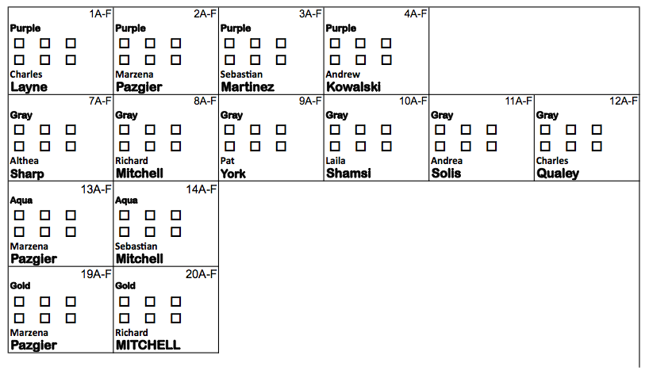
- Use mixed case instead of ALL-CAPS for the party names and candidate last names, if legally allowed by New York State statute, following guidelines from the EAC best practices guidelines and the Brennan Center.

Satisfaction Results
We asked participants to rate their reactions to seven statements (shown in the left column in each table below). These subjective ratings data are based on a 5-point scale, from Strongly agree to Strongly disagree (along with an option to skip a question). Participants were asked to rate their overall satisfaction with the voting experience, including both paper ballots and the lever machine.
Note that the first 4 questions are stated positively, so agreement is a sign of good satisfaction, while the last 3 are stated negatively, so disagreement is a sign of good satisfaction. These questions were alternated on the actual questionnaire.
Number of participants who responded with each ranking (N=18)
Questions | Strongly agree | Agree | Neutral | Disagree | Strongly disagree
Positively worded questions (agreement is good)
I thought the ballot was easy to use | 4 | 9 | 3 | 1 | 1
It was easy to mark my choices | 5 | 7 | 4 | 1 | 0
I would imagine that most people would be able to use this ballot without problems | 2 | 3 | 3 | 9 | 1
I felt very confident casting my vote using this ballot | 3 | 7 | 4 | 3 | 1
Negatively worded questions (disagreement is good)
The instructions for this ballot were difficult to understand | 0 | 4 | 3 | 6 | 4
I found this ballot awkward to use | 1 | 7 | 6 | 3 | 1
I would need help to use this ballot | 3 | 5 | 1 | 3 | 5
The answers to some of the questions indicate possible usability problems, or discomfort using the new ballot with cumulative voting:
- A large number of participants (13 of 18) indicated that they thought “most other people” would not be able to use the ballot without problems.
- An equally large number (14 of 18) said they found the ballot at least somewhat awkward.
- The participants were split (8 positive, 8 negative, 1 neutral, 1 declined) on whether they would need help with the ballot. This was one question that showed a bias based on ethnicity: almost all of the Latinos agreed that they would need help; almost all of the whites disagreed. This suggests a strong need for voter education to prepare voters for cumulative voting.

Detailed Results
All of the paper ballots had the same instructions at the top. The lever machines had the normal voting instructions on the side, and additional instructions for cumulative voting across the top.
Instructions in English | Instructions in Spanish
  VILLAGE ABSENTEE VOTER'S BALLOT
  PORT CHESTER BOARD OF TRUSTEES
  Six (6) At-large positions open for 2 years- 9 month terms
  Voting Instructions:
  To vote, fill in the square(s) above a candidates name, like this: [ ]
  Use blue or black ink.
  To vote for a person whose name is not on the ballot, write the person’s full name in the blank space at the bottom and fill in the square(s) above the name.
  Do not write or make a mark or erasure anywhere outside of the voting boxes or blank spaces for voting, or your ballot will be voided (will not be counted).
  If you tear, deface, or wrongly mark this ballot, return it and obtain another.
  Cumulative Voting Instructions:
  Vote for one, two, three, four, five or six candidate(s).
  You have a total of 6 votes.
  You can cast your 6 votes in any combination.
  You can vote up to 6 times for one candidate.
  Do not cast more than 6 votes.
  TRUSTEE (2 YEARS & NINE MONTHS) SIX POSITIONS
  BOLETA DEL VOTANTE AUSENTE DEL PUEBLO
  JUNTA DE SINDICOS DE PORT CHESTER
  Estan abiertos para cubrir seis (6) puestos por un término de 2 años y 9 meses
  Instrucciones en cómo votar:
  Para votar, llene la casilla o casillas arriba del nombre del candidato, así: [ ]
  Use tinta negra o azul.
  Para votar por una persona cuyo nombre no esté en la boleta, escriba el nombre completo de la persona en el espacio en blanco localizado en la parte inferior y marque el cuadro arriba del nombre.
  No marque escriba o borre fuera de las casillas de votación o en espacios en blanco para votar, o su boleta será anulada (no será contada).
  Si usted rompe, desfigura, o marca en forma errada la boleta, regrésela y obtenga una nueva.
  Instrucciones sobre el Voto Acumulativo:
  Usted puede votar por uno, dos, tres, cuatro, cinco o seis candidato(s).
  Usted tiene un total de seis (6) votos.
  Usted puede emitir seis votos en cualquier combinación.
  Usted puede votar hasta seis veces por un candidato.
  No puede emitir más de seis (6) votos.
  SÍNDICO (Por un término de 2 Años y Nueve Meses) SEIS PUESTOS.

Success details
The majority of the votes were cast successfully. That is, the participant cast 6 valid votes. In most cases, they also successfully followed the directions given to them for how to vote.
Ballot/Task (N=72) | Success | Undervotes | Overvotes
Lever Machine (Red) | 13 | 5 | 0
Paper (Green) | 11 * | 5 | 2
Paper (Blue) | 10 | 6 | 2
Paper (Yellow) | 10 * | 6 | 2
Total | 34 | 22 | 6
* Some people (2 for Green, 3 for Yellow) cast 6 votes, but made their own choices
- The even distribution of successful, undervoted and overvoted ballots shows that there was not a strong “learning effect” because the order in which participants voted these ballots was counterbalanced with a standard rotation of the order.
- All of the overvotes were cast by the same two people. On all of the paper ballots, they filled in all of the squares for each of the candidates they wanted to vote for.
- Of the 8 participants who undervoted 22 times, most of the errors were in voting 1 time for each candidate named, and not casting any additional votes to complete the ballot.
  - 3 participants undervoted only on their first ballot, but did not make this mistake for the other ballots. Two of them voted first on the lever machine, and later said they did this out of habit.
  - 5 participants were consistent in their undervoting pattern across the 4 ballots (2 on all ballots, 2 on all paper ballots, 1 on all but one)
  - 2 undervoted on just one ballot, possibly due to miscounting.
  - There is no strong correlation between undervoting and race/ethnicity.
Participants who undervoted
P# | Ethnicity | First | Red (5) | Green (5) | Blue (6) | Yellow (6)
P1 | Black | Red | Yes | No | No | No
P17 | White | Red | Yes | No | No | No
P13 | Latino | Green | No | Yes | No | No
P4 | Latino | Blue | Yes | Yes | Yes | Yes
P6 | Black | Yellow | Yes | Yes | Yes | Yes
P15 | Latino | Blue | No | Yes | Yes | Yes
P18 | White | Red | No | Yes | Yes | Yes
P12 | White | Blue | Yes | No | Yes | Yes
P8 | Latino | Blue | No | No | No | Yes
P5 | Latino | Green | No | No | Yes | No

Red ballot (lever machine)
Instructions: You want to vote for candidates Althea Sharp and Benjamin Garcia. Vote for them, and then complete your ballot in any way you want.
Usted quiere votar por los candidatos Althea Sharp y Benjamín García. Vote por ellos, y después llene su boleta electoral de cualquier manera que guste.
About the task: Each of these candidates appeared only once on the ballot. Althea Sharp was in the Grey party at the left side of the machine; Benjamin Garcia was a Petition candidate at the far right side. A successful ballot for this task would divide their 6 votes between these two candidates.
About the ballot: The machine was laid out with each candidate occupying one column of 6 levers. They were grouped by party, with a blank column between the parties. The strips of paper on the ballot face with the candidate names were in colors, matching the colors of the party.
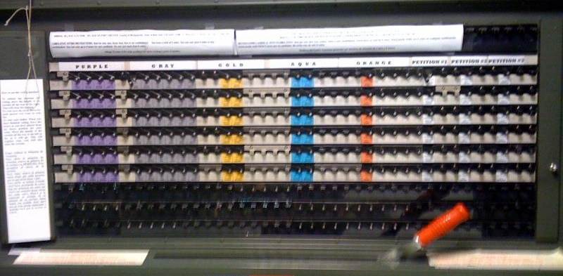
The machines were stiff, because they had not been used recently. This was particularly true for levers at the bottom of the columns, and at the far right end.

How they voted on the red ballot
Success (13) | Undervotes (5) | Overvotes (0)
8 – cast 3 votes each  5 – cast another combination | 4 – cast 1 vote each  1 – cast 5 votes (miscounted) | none

- They all had to hunt to find the correct names. Several commented that it was difficult to read the ballot and many had to stoop to do so. They all quickly realized that the same name was repeated down the column, so they only had to read the first row.
- Most (13 of 18) successfully cast a ballot with 6 votes. Some split their votes between the two candidates. Others decided on their own combinations. Most of these combinations either gave extra votes to Garcia, or added votes for Martinez (one of the other Spanish names on the ballot). One of the undervotes was a mistake, as the voter miscounted the number of votes already cast.
- The 4 other undervotes all made the same mistake: they found the candidates, turned the top lever for them, and said they were done. All of these participants were confident voters. When asked about it after the task, each one said that they had “forgotten” about the 6 votes, carried along by their habit of voting just once for a candidate.
- The lever machines do not allow overvotes. Several of the participants tried to cast too many votes and were stopped by the machine. One participant who undervoted by 1 vote, however, may have had trouble with the lever, and mistakenly believed that they had cast all their votes.

Green ballot
Instructions: You want to vote only for candidates from the Purple party.
Usted quiere votar solamente por candidatos del partido Morado.
About the task: The challenge in this task was that the Purple party had only 4 candidates. A completely successful ballot for this task would mark 6 votes, dividing votes among the Purple candidates.
About the ballot: The Purple party was on the top line of the ballot.
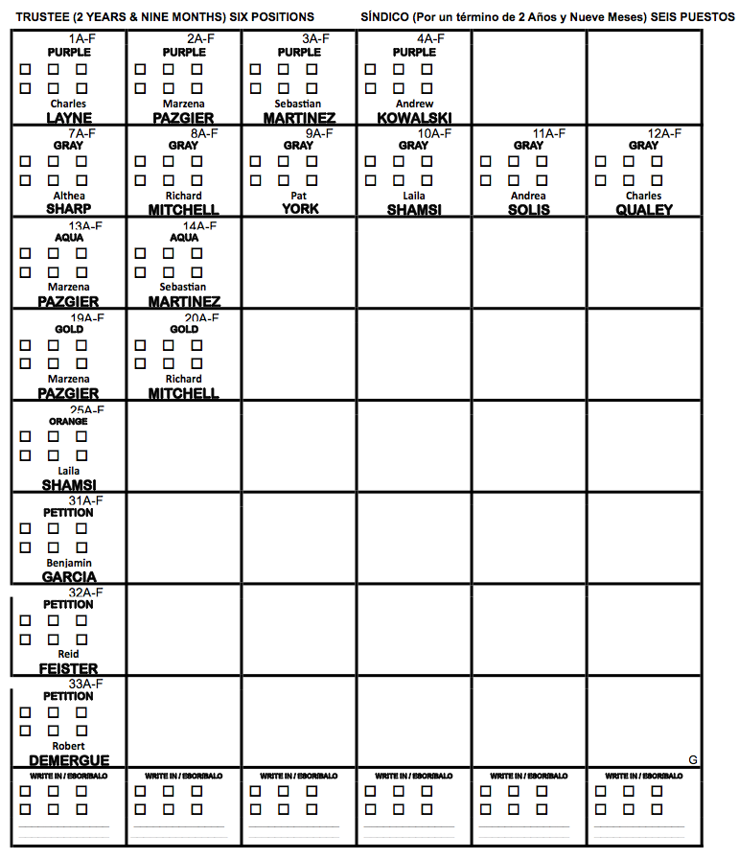

How they voted on the green ballot
Success (11) | Undervotes (5) | Overvotes (2)
9 – 6 votes for the Purple  candidates  2 – 6 votes for own choice  (some not Purple) | 5 – 1 vote each for the 4  Purple candidates | 2 – 6 votes each for the 4  Purple candidates

- Most (11 of 18) successfully cast a ballot with 6 votes. Of the 9 who voted only within the Purple party, there were several combinations:
  - 2 votes each for 3 candidates
  - 2 votes for 2 candidates and 1 for the other 2
  - 3 votes for 1 candidate, and 1 for the other 3
  - All 6 votes for 1 candidate
- All of the undervotes (4) made the same mistake, voting 1 time for each of the 4 candidates and not casting any other votes.
- The 2 overvotes both made the same mistake, voting 6 times for each of the 4 candidates.

Blue ballot
Instructions: You want to vote only for candidates Pat York, Robert Demergue, and Richard Mitchell. You want to vote for Pat York as an Aqua Party candidate.
Usted quiere votar solo por los candidatos Pat York, Robert Demergue, y Richard Mitchell.
Usted quiere votar por Pat York como candidato del Partido Azul.
About the task: The challenge in this task was to find a fusion candidate on the second party line. The three candidates named in the instructions were in three different parties: Demergue in Purple, Mitchell in Gray, York in both Purple and Aqua. A completely successful ballot would include votes for only these candidates, with at least some of the votes for York on the Aqua party line.
About the ballot: The Purple party was on the first row, Gray on the second, Aqua on the third.
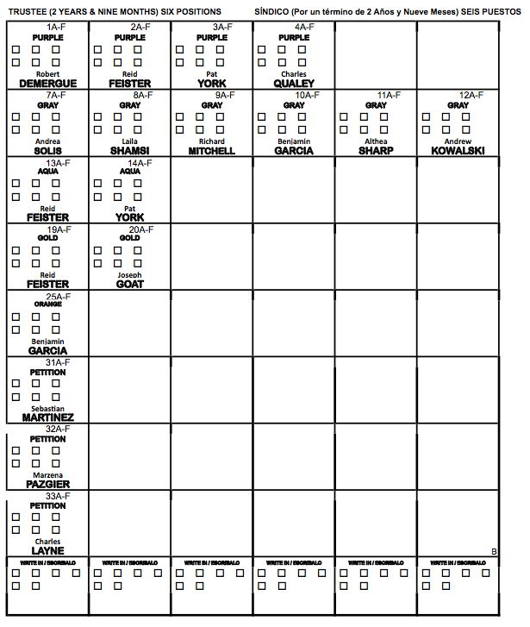

How they voted on the blue ballot
Success (10) | Undervotes (6) | Overvotes (2)
6 – cast 2 votes each  3 – cast another combination  1 – cast with write-ins | 3 – cast 1 vote each  2 – cast another combination  1 – York + 2 write-in on Aqua line | 1 – cast 6 votes each  1 – cast 6 votes for 4  candidates and 2 for  another

- Most (10 of 18) successfully cast a ballot with 6 votes. 7 split their votes evenly among the 3 candidates, and 3 decided on their own combinations. One did so by writing in one of the candidate names for two additional votes
- 4 of the undervotes repeated the mistake of casting just one vote for each of the named candidates; One did so with an unusual write-in method (which might not be counted
- 11 of the participants successfully found the candidate on the Aqua party line and votes for him there. A few had already marked one vote for that candidate on the Purple party, so added a second vote on the other party.
- 2 participants overvoted in an interesting way: by marking all 6 boxes for the candidates they chose (1 found the correct candidate names and parties, the other marked 4 candidates with 6 votes and one more with 2).

Yellow ballot
Instructions: You want to vote for candidates Sebastian Martinez, Reid Feister, Laila Shamsi, Charles Qualey, and Charles Layne. You are a supporter of the Orange party.
Usted quiere votar por los candidatos Sebastián Martines, Reid Feister, Laila Shamsi, Charles Qualey, y Charles Layne. Usted es un partidario del partido Naranja
About the task: This task named only 5 candidates, and included a preference for a party for which one candidate appeared as a second line. A completely successful ballot for this task would include votes for the 5 named candidates, including at least one on the Orange party, with the 6th vote given to any candidate (including the named ones).
About the ballot: These candidate are 5 of the 6 candidates on the Gray party line. One candidate, Qualey also appeared on the Orange party line.
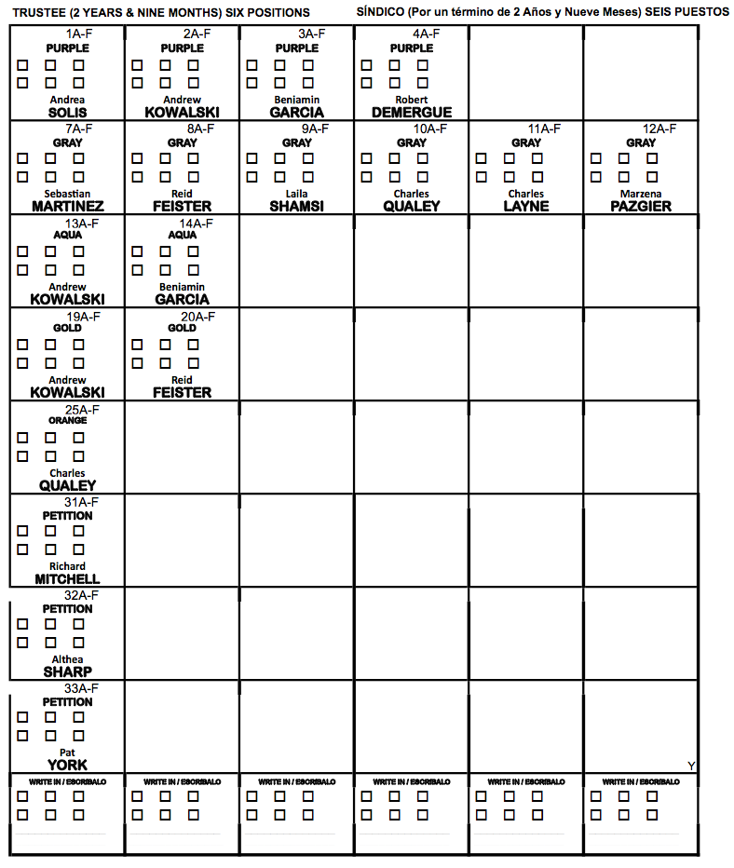

How they voted on the yellow ballot
Success (10) | Undervotes (6) | Overvotes (2)
3 – all named candidates  3 – subset of candidates  1 – all on Orange party  writing in 4 names on  this line  3 – own choices | 2 – 1 vote each on Gray  1 – 1 vote for each on  Gray and Orange  1 – 1 vote on Orange  1 – 5 votes on Orange  1 – own choices | 1 – 6 votes each for  5 candidates on Gray  1 – 6 votes each for 5  candidates on Gray and  1 on Orange

- Most (10 of 18) successfully cast a ballot with 6 votes. 4 voted in some way for all of the candidates named, 3 for a subset of the candidates, 3 made their own choices for this task.
- 11 of the ballots included at least 1 vote on the Orange party line.
- Most of the undervotes (4) voted just once for each named candidate, though on different party lines. One undervote was a single vote on the Orange party line. One was for their own choices.
- 2 participants overvoted in an interesting way: by marking all 6 boxes for the candidates they chose (1 marked just the 5 candidates on the Gray party line. The other added votes for the candidate on the Orange party line).
- One participant made an interesting choice, and wrote the names of the 4 Gray party-only candidates in boxes on the Orange line. She said that the instructions said they a voter could vote for a candidate on “any party line” so she was moving them to the party the instructions said she had a preference for.

Samples of ballot markings
Squares selected by row from upper left | 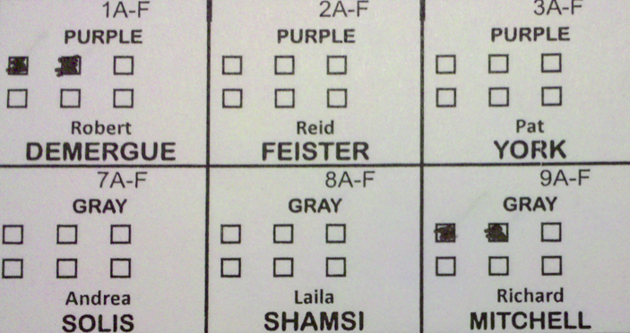
Squares selected by column from upper left | 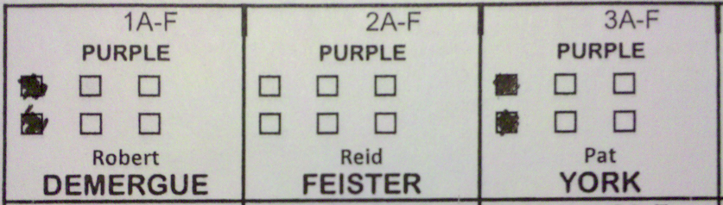
Squares selected from upper right | 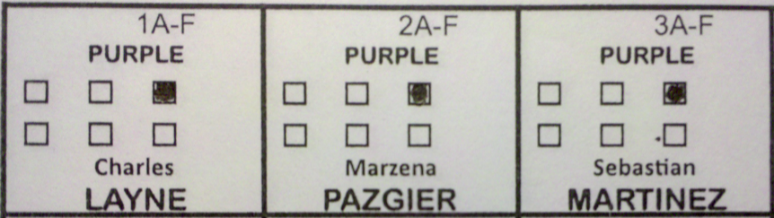
Squares selected from bottom right | 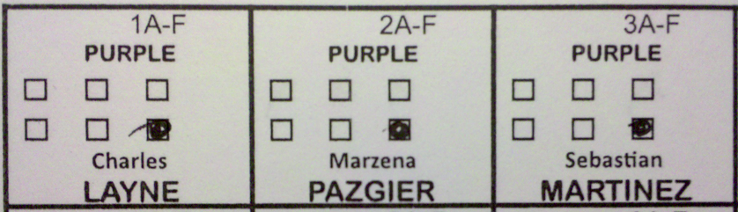
Poorly marked squares | 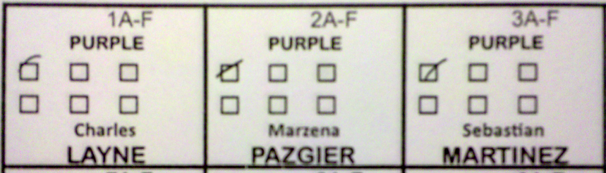
Random pattern | 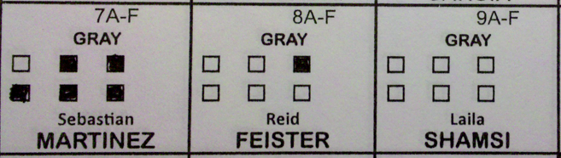
Check marks | 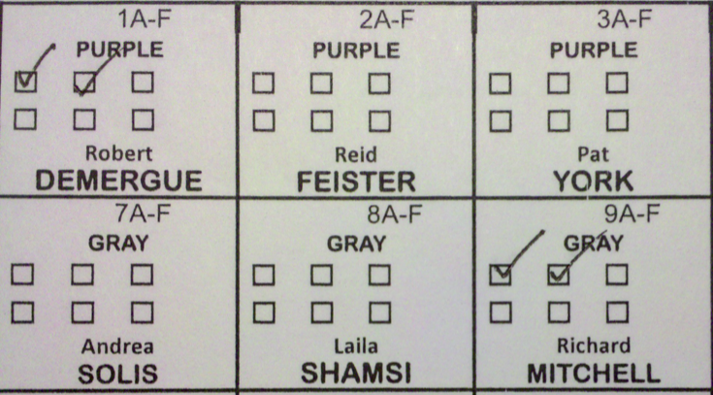
Write In | 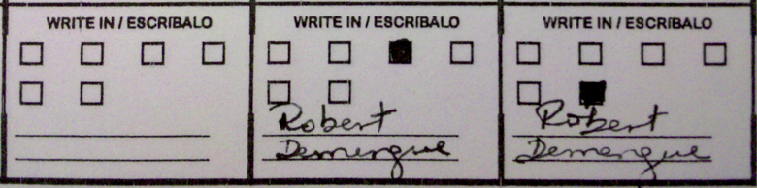
Write In | 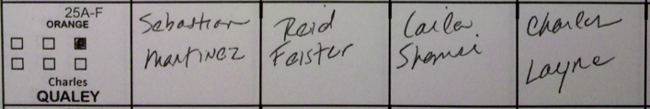
Write In | 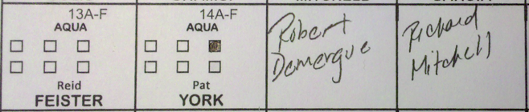
Overvote | 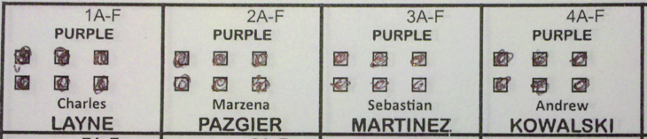

Report of Findings: Use of Language in Ballot Instructions, NIST IR 7556, by Ginny Redish, Dana Chisnell, Ethan Newby, Sharon Laskowski and Svetlana Lowry (May 2009). Available from http://vote.nist.gov/NISTIR-7556.pdf, linked from http://vote.nist.gov/docmap.htm
Cognitive research suggests that lines in a table are processed as a discrete semantic element, just like a textual element.
Effective Designs for the Administration of Federal Elections, http://www.eac.gov/election/effective-polling-place-designs
Better Ballots, by Lawrence Norden, David Kimball, Whitney Quesenbery, and Margaret Chen, The Brennan Center (August 2008). http://www.brennancenter.org/content/resource/better_ballots/

