This is the Permanent VBM Reminder template
Use this template if the voter will continue to automatically receive a ballot even if they don’t respond.
- Voters automatically remain on the list and automatically receive a mail ballot.
- This mailer is an opportunity to remind the voter when they can expect their mail ballot and include other voter education.
- The notice reminds voters to get ready to vote by mail.
- The form gives the option to update information, and be removed from the list.

Date sent (MM/DD/YYYY)
VOTER NAME
5555 VOTERSTREET STREET
VOTERTOWN, SS 12345-1234

Get ready to vote by mail!
Thank you for being a Franklin County voter! You’ll receive a ballot in the mail for the 2026 November General Election because you’re on the permanent absentee list.

Make sure your voter information is up-to-date by Month DD, YYYY

Review your information on the back of this notice.
If your information is accurate, do nothing. Your ballot will arrive in a few weeks.
If you need to update your information, you have 2 options:

Online — Save time by completing the form at vote.yourtown.gov/VBM

By mail — Sign and mail this back. Use the return envelope provided.

If you have questions, contact our office!
We are open 8 AM - 5 PM, Monday through Friday.

Online - Find more information and track your ballot status at vote.yourtown.gov/VBM
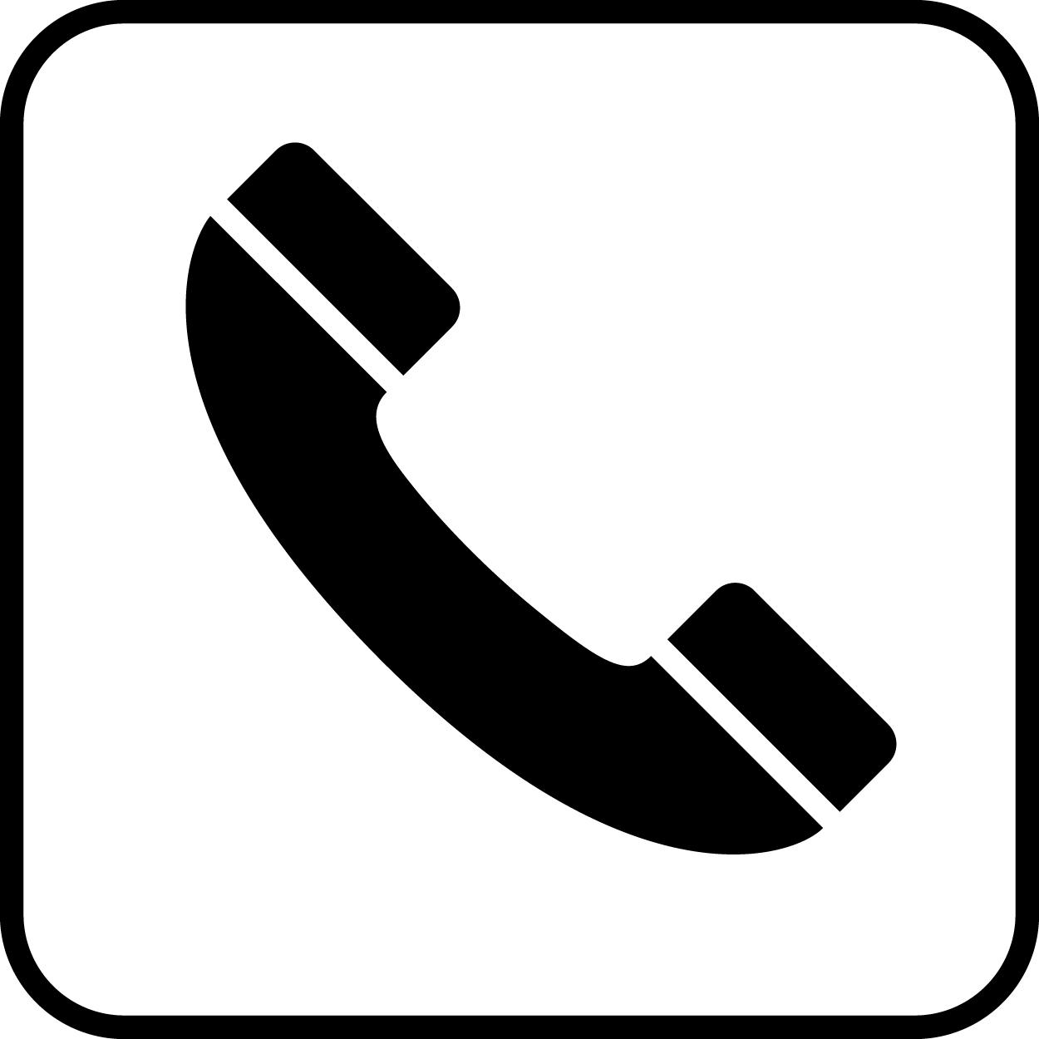

By phone at 800-555-5555
In person at 555 W Streetname Street, Townname, ST 55555

Turn over to update your information | 

To update your information, complete and return this form
If your information on the left is not correct, use the boxes on the right to write the correct information.
Your residential address:  Voter Name  5555 VOTERSTREET STREET  VOTERTOWN, SS 12345-1234 | Update my residential address:
Where your ballot will be sent:  Voter Name  321 Freedom St.  Newton, HT 12346 | Update my ballot mailing address:
If you use unique voter identifiers, include that here

You can also ask to stop receiving this notice every year
☐ Remove me from the permanent ballot list and stop sending me ballots every year. I understand that to vote by mail in the future, I must complete an application again.

VOTER NAME, sign here (Required)
X |  | Today’s date:  ________/________/__________

