Thank you for being a voter! Your vote-by-mail ballot is enclosed. This booklet contains information about how to vote by mail. Return your ballot so that we receive it, or it is postmarked by 8pm on Election Day.

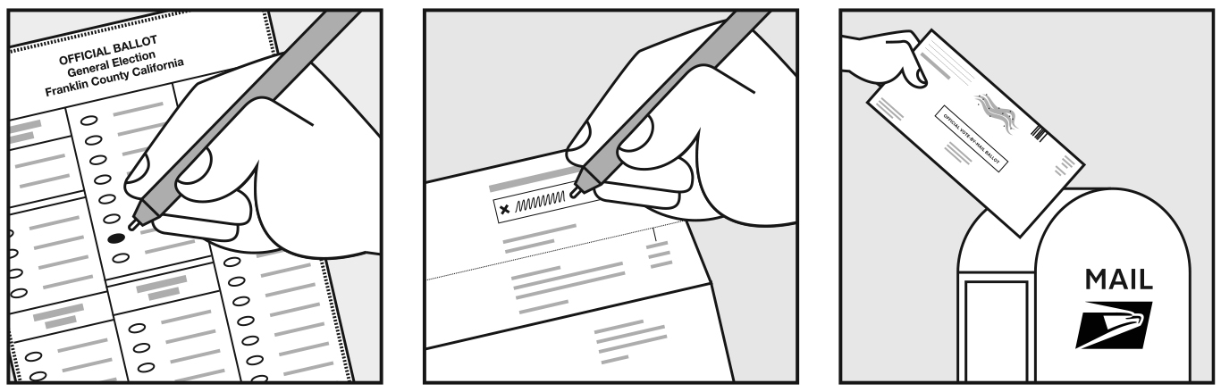

Mark ballot Sign and seal envelope Mail ballot Bring ballot to General Registrars’ office

How to vote by mail
Find a witness to watch you open your vote by mail envelope
- Your witness can be anyone who is not your employer.
- If you want to vote in person, do not open your envelope. Bring your sealed envelope with you to vote in person.
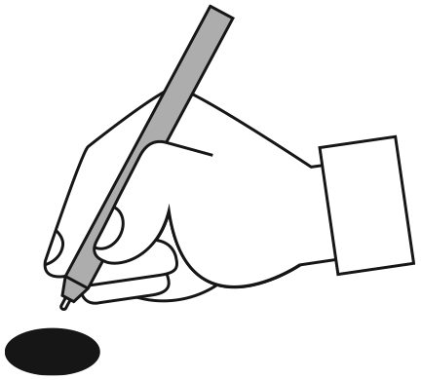
Open your envelope and and mark your ballot
See the ballot for instructions. Remember to:
Open your envelope in front of a witness. Your witness should not watch how you fill in the ballot.
Fill in oval completely to mark your choice.
Vote only for the number of candidates allowed.
If you make a mistake or lost your ballot, you may be able to get another ballot.
  - Contact your local General Registrars’ office for more information.
Sign and seal your envelope
Follow the instructions on the envelope. Check that:
you put your ballot into the return envelope B.
you filled in your residential address for where you live. This should be the same address you used for your voter registration.
you filled in the date and signed your name.
your witness filled in the date and signed their name.
Turn over to learn:
- how to mark your ballot if you need assistance
- how to return ballot
- how to contact us with questions
If you told us that you need assistance filling in your ballot
We included a Request for Assistance form with your ballot.
Remember to:
- fill in the Request for Assistance form before voting.
  - If voter cannot sign, write voter’s full name and write ‘applicant cannot sign’ in voter’s signature box.
  - If you are assisting blind voters only, print the voter’s full name and write ‘Blind Voter’ in the voter’s signature line.
  - Assistant, print name and address in assistant section.
- place Request for Assistance form in the xx envelope. This form goes in a separate form than the ballot.
If you no longer need assistance, do not return the form. Mark ballot as without assistance.
You have 2 options to return your ballot:
Mail your ballot so that it is received before 7:00 pm on Election Day November 3, 2020.
You can mail your ballot through:
- United States Postal Service (USPS). Remember to add postage.
- Return it by a commercial delivery service, such as UPS, FedEx, or DHL.
Deliver your ballot to the General Registrar’s office or to a member of the Electoral Board during business hours or until 7:00 pm on Election Day.
We are open 8:00 am – 5:00 pm Monday - Friday
Our address is:
100 Main Street, Suite 0000
Washington County, VA 11111

A few things to avoid:
- Do not ask someone to deliver your ballot on your behalf.
- Do not leave your voted vote by mail ballot in a polling place.
If you do either of these, we cannot accept your ballot and your vote won’t count.
We’re here to help! Contact us with any questions.
- Check our website: www.elections…..
- Confirm the date your ballot was received by your elections office at: ww.elections…..
Send us an email: elections.gov…
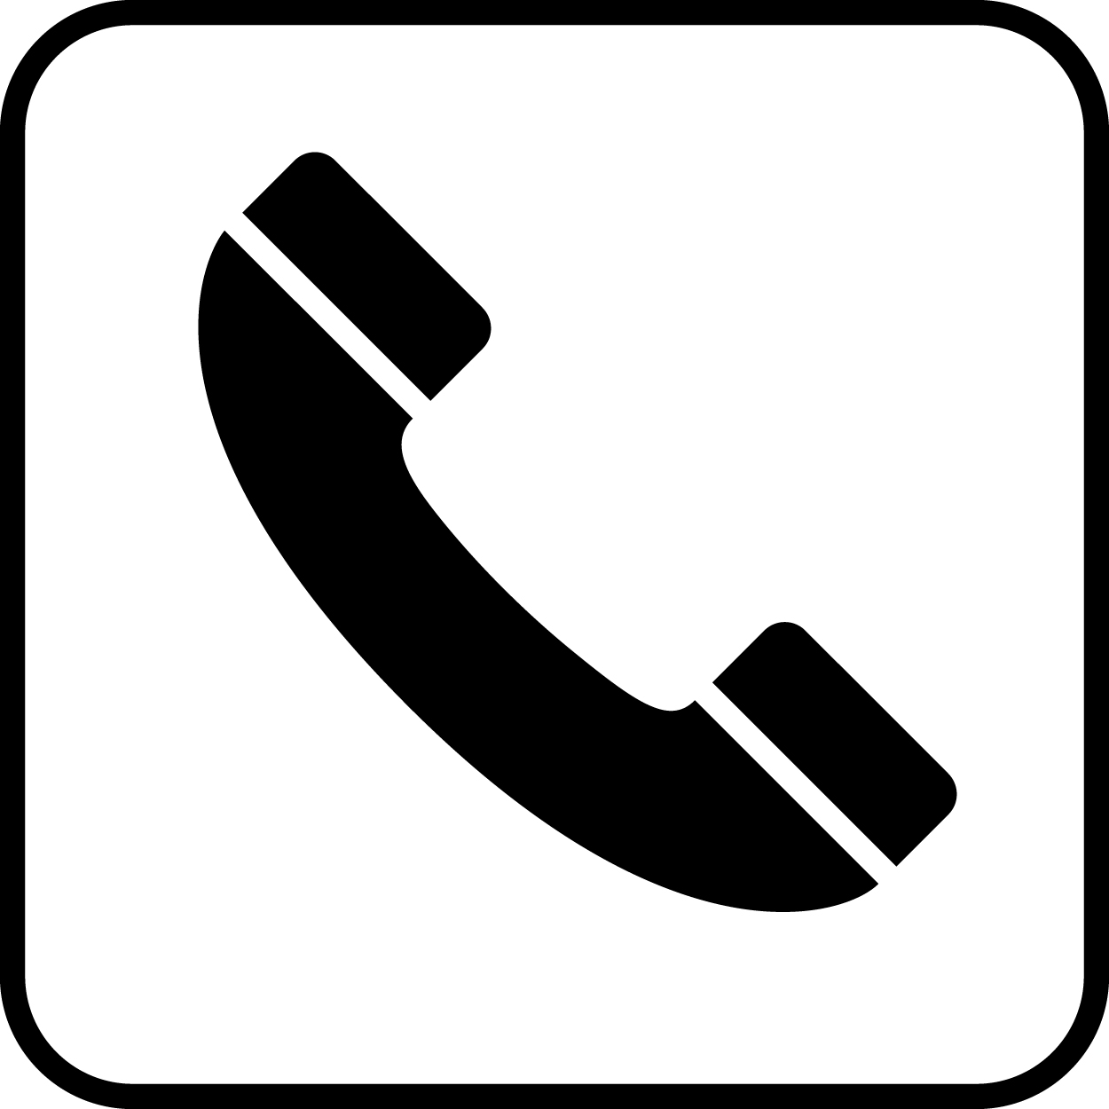
Reach us by phone: 111-111-1111

