|  |
| --- |
| **Vote by mail envelope templates** |
| **Labels for sending ballots between counties** |



Use this label template to forward any ballot envelopes that end up in your office, but belong to a different county.

About this template:

* This is not a one-size-fits-all template. Our goal was to give you a starting point that you can customize to work with your policies and practices.
* If the county’s envelopes use a color other than purple on their return envelopes, change the color of the label to match. This helps USPS recognize the envelope and get to the right county’s office.
* Print these this template using a full sheet label. Then cut in half.

We’re always here to help! Get in touch at [hello@civicdesign.org](mailto:hello@civicdesign.org).

Name of Origin County   
Elections Department

Address 1

City, State ZIP

­

Official Ballots

­­

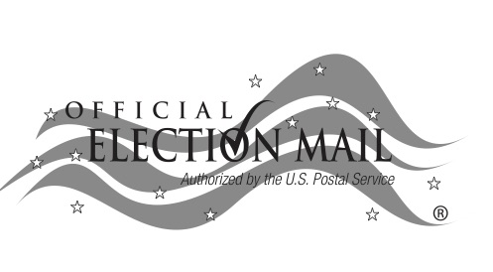



Deliver to

County Name

Elections Office

General Election  
11/3/2020

Deliver to

County Name

Elections Office

General Election  
11/3/2020

Name of Origin County

Elections Department

Address 1

City, State ZIP

Official Ballots

**County Name**

**Elections Department**  
Address 1

Address 2

City, State ZIP

**County Name**

**Elections Department**  
Address 1

Address 2

City, State ZIP