Supporting the implementation of the Voter’s Choice Act:
Designing job aids for effective vote centers
Role- and task-based materials for vote centers
August 2018
Dana Chisnell
Maggie Ollove
Center for Civic Design

Role- and task-based materials
for vote centers
Vote centers change the experience for voters. With precinct-based polling places, there’s one place to go on a specific day. When jurisdictions adopt vote centers, voters can vote at any vote center, or they might drop off a vote-by-mail ballot. At a vote center, voters meet a simpler process than they typically would encounter at a precinct-based polling place and can receive assistance or information they might need. Vote centers also change how election workers work.
The passage of the California Voter’s Choice Act presents an opportunity to upgrade not only the voter experience, but also the experience election workers have. A key element of the experience workers have comes through the supporting materials they learn from and work with every day.
In this project, we started from what we have learned on earlier, related projects, and reviewed existing work of others about staffing and managing vote centers. We interviewed election officials who have staffed vote centers (or early voting equivalents). We used all of these inputs to develop general principles, guidelines, and templates for vote center materials that meet vote center workers where they are – in the roles they work in and the tasks they’re doing.

Summary insights
Adult learners are self-directed, goal-oriented, and are driven by learning what is relevant to them. These principles tell us that poll workers are more likely to learn what they need to do and carry out the right procedures at the right time when they have guiding principles to work from, and get practice performing procedures in realistic situations. Adults learn through experience.
When following instructions, people in the U.S. tend to read a step and then follow it, rather than reading all of the steps and then performing the task having reviewed the entire job. So, people working in what can be high-stress, high stakes situations in vote centers need the right materials at the right level at the right time.
There is a large body of literature from instructional design and technical communications on how best to write and present information to users who are reading to do, as election workers are. NIST has published a version of the most important guidelines in NIST IR 7519, Style Guide for Voting System Documentation. They include:
- Write the documentation to specific users and address one group of users at a time.
- Organize the information to meet users’ needs, focusing on users’ tasks.
- Use simple words and avoid jargon.
- Write directly to users, using active voice.
- Keep instructions short and simple.
In this project, we learned that California election officials expect that recruiting and managing vote center staff will be different from precinct-based polling. In the California 2018 statewide primary, this was true for the first 5 counties to implement the Voters Choice Act.
Vote center staff is likely to be:
- long-term temporary workers, hired full time for the duration of early voting, rather than one-day paid volunteers
- sourced from a pool of known workers who are already known
- working more as “customer service,” processing each voter through all of the steps of voting, rather than staffing a particular station related to a step in the process.
In this project, we sought to apply adult learning principles and cross-discipline insights to materials for vote center workers. We rethought the role of reference documentation and checklists in polling places, and reconfigured materials.
While there are differences between precinct-based polling places and vote centers, we’re confident that the tools we developed would work well in both.

About the project
When California’s Voter’s Choice Act (VCA) passed in 2017, the Future of California Elections consortium organized to help local election officials get ready to implement the changes. VCA allows counties to – among other things – set up vote centers for early voting. While some counties have been running early voting with a model similar to vote centers for a while, most counties have not.
The Center for Civic Design sought to develop materials specifically for people working in vote centers. Our research for this project shows that the nature and rhythm of the work in vote centers is different from precinct-based polling. We learned that the staffing and management of workers should be different, too.
We started by reviewing available materials on vote center management, which included information about roles and tasks. Then we interviewed election officials inside and outside California who have set up and run vote centers to learn about their experiences and to extract best practices.
We met with California election teams at CACEO in July 2017 to interview them specifically about their plans for implementing VCA and their practices around recruiting, training, and managing poll workers. We also learned what counties expected to do differently in running and staffing vote centers from precinct-based polling.
Even before VCA, over many years, because of the work we do, we have visited polling places across the U.S., and interviewed dozens of poll workers about their experiences in a range of different types of elections. (We have even worked the polls ourselves.) We’ve collected and analyzed training manuals and job aids from across the U.S. and Canada. We rolled all of this learning into developing VCA vote center worker support, too.
During early voting for the California 2018 primary, we visited 3 vote centers in 2 counties to see what they were like and how it was going.

Insights from research with poll workers
In research we conducted across the country in 2012 and 2013 with poll workers in precinct-based polling places, we were surprised by some of the variation in how poll workers understood their role in good elections and election security.
We saw four broad classifications of attitudes among the poll workers we met, from a shallower to deeper sense of ownership of the polling place.

Attitudes toward responsibility for the polling place
Attitude | Focus of responsibility
I’m responsible for running the polling place | Safety and comfort of voters, and maintaining an orderly polling place.
I have to follow procedures | Completing all procedures correctly, as a way of running the polling place well.
I have to account for paperwork | Forms and reports as a double-check on equipment tallies and to ensure that all votes are accounted for.
I’m responsible for “my election” | The overall results of the election, broadly incorporating the polling place, procedures, and tallies.

These attitudes were influenced by many factors: personal history, election culture, voting equipment and how long it had been in service, who managed the team, local policies, leadership of the election director or clerk, and changes in laws.
We think that understanding these attitudes is important for hiring, training, and evaluating vote center workers. Our theory is that as vote centers focus more on customer service, the focuses of responsibilities listed above translate to objectives for the workers.

Polling place materials and procedures can help or hinder
In the places we studied, some poll workers encountered piles of paperwork. Others had very little in the way of printed tools and support. Getting the amount of process and forms right was elusive. We call this the “Goldilocks Problem.”
The amount of paperwork associated with an election—in addition to ballots and tallies—would surprise many people. Starting with poll worker manuals—which can have 200 to 400 pages—given out at training, and ending with reconciliation sheets and equipment and supply inventory sheets, the checklists and documentation of elections can generate reams of paper per poll worker.
Or they might not. Some jurisdictions we studied took a minimalist approach. Poll workers got a 100-page manual, a dozen forms for documenting tallies and incidents, a poll book, and the phone number for the elections office.
Some poll workers had to guess or make a lot of calls because manuals were lacking or checklists didn’t exist. Other poll workers spent as much time sorting through the paperwork that was supposed to be helping them as they did doing the work the checklists were meant to support.
Good tools don’t get in the way. They help poll workers attend to their tasks.
In our visits to California vote centers in May 2018, we saw that counties seemed to have found the “just right” amount of training and support documentation. It was role- and task-based, with just what the person needed at the given station. Documentation for running equipment was separate.

Tool time versus goal time
People who work in user experience design or service design call this kind of design problem a tradeoff of time spent on tools versus meeting goals. When working with the tools creates a distraction from meeting the goal, there are two costs: one for the time it takes to pay attention to the tool, and another for the loss of focus on the goal. Even good tools can add work, but ideally, tools should not get in the way, taking poll workers’ attention away from their tasks.
We wondered how the extremes got to be that way. Two factors seem to be at play:
- the desire to improve poll worker performance with each election
- patching holes in processes and procedures rather than taking a holistic view of causes of problems.
In follow-up interviews with poll workers and election administrators in our 2012-13 study, we heard that of course every jurisdiction works to improve elections every time. Administrators meet with poll workers to gather feedback and ideas for making improvements. They also assess polling place incident logs, media coverage, and reports from call centers. From all this data, they make changes to forms, processes, and training.
How the changes get incorporated makes a difference in how elections go the next time. Ideally, the data and changes would be part of a broad review of processes and procedures that should flow together. It was more often the case that issues discovered in any one election were handled individually. When this happens, jurisdictions tended to add forms, steps, checklists, or training. It is possible that managing changes this way introduced other problems. For example, adding checklists ended up creating a kind of meta task in some jurisdictions—the checklists got a checklist.
We saw no evidence that more paper was a sign of a better, more secure election. Nor did we come away thinking that the minimalist jurisdictions were lacking.
We were happy to see less paperwork in 2018 vote centers. Some of the reporting, reconciling and checklists are subsumed by new technology that can track and report some information automatically. When the technology works well for users, workers can focus on providing service to voters.

How much paper is the “right” amount?
Much of the Goldilocks Problem lies with the amount of paper involved in documenting elections. While we saw some very good manuals, checklists, and job aids, nearly all the examples we collected in 2012-13 could be improved by applying research-based best practices, and by conducting usability testing on them (in addition to the “live” testing they get on Election Day).
The paper—forms, checklists, job aids, and manuals—interacts with training, too. Much of the training we have observed did not include practice and hands-on experience. However, one of the best activities we did see was an exercise where poll workers responded through role-play to flash card scenarios to practice how to respond to problematic situations. We saw this in practice in California VCA counties’ materials in training we observed.

Materials can help prevent errors
In our 2012-13 study, even within some of the jurisdictions that seemed the most thorough and organized, some procedures did not make sense to poll workers. The procedures aren’t complete or accurate or clear, or they are buried in a large manual. So poll workers generally try to do their best. They rationalize and improvise, which usually results in a good outcome.
We know that election administrators try to make everything accurate, complete, and easy to use. But it doesn’t always work out that way. One of the best practices of designing user interfaces and user assistance is to prevent errors. If users do make mistakes, help them recover quickly and easily. It takes time and attention to troubleshoot problems, so the fewer and shorter any troubleshooting episodes there are, the better. Any troubleshooting or improvising procedures is an opportunity for an attacker, and degrades the experience of voters.

Procedures and operations
We saw some general practices in 2012-13 that seemed to be effective ways to ensure security and efficiency in the polling place. Among them:
- Before opening: Crosschecking set-up steps between precincts in a multi-precinct polling place is an opportunity for a procedural check.
- During Election Day: Continuous reconciliations make it possible to find and fix problems early.
- During Election Day: Like continuous reconciliations, frequent checks and double-checks on the ballot count during the day make closing and shutdown faster.
Among the prominent observations are these:
- The best practices in polling place work need thorough, timely checklists.
- Standard training includes issuing manuals to poll workers. Often the manuals are hundreds of pages long.
- The manuals often include too much information that is not organized for easy reference. The expectation seems to be that poll workers will read and memorize the manuals.
- The manuals include reference information for multiple roles, based on equipment rather than being organized around tasks.
- Poll workers rarely refer to their manuals on Election Day, even though information they need is documented there.
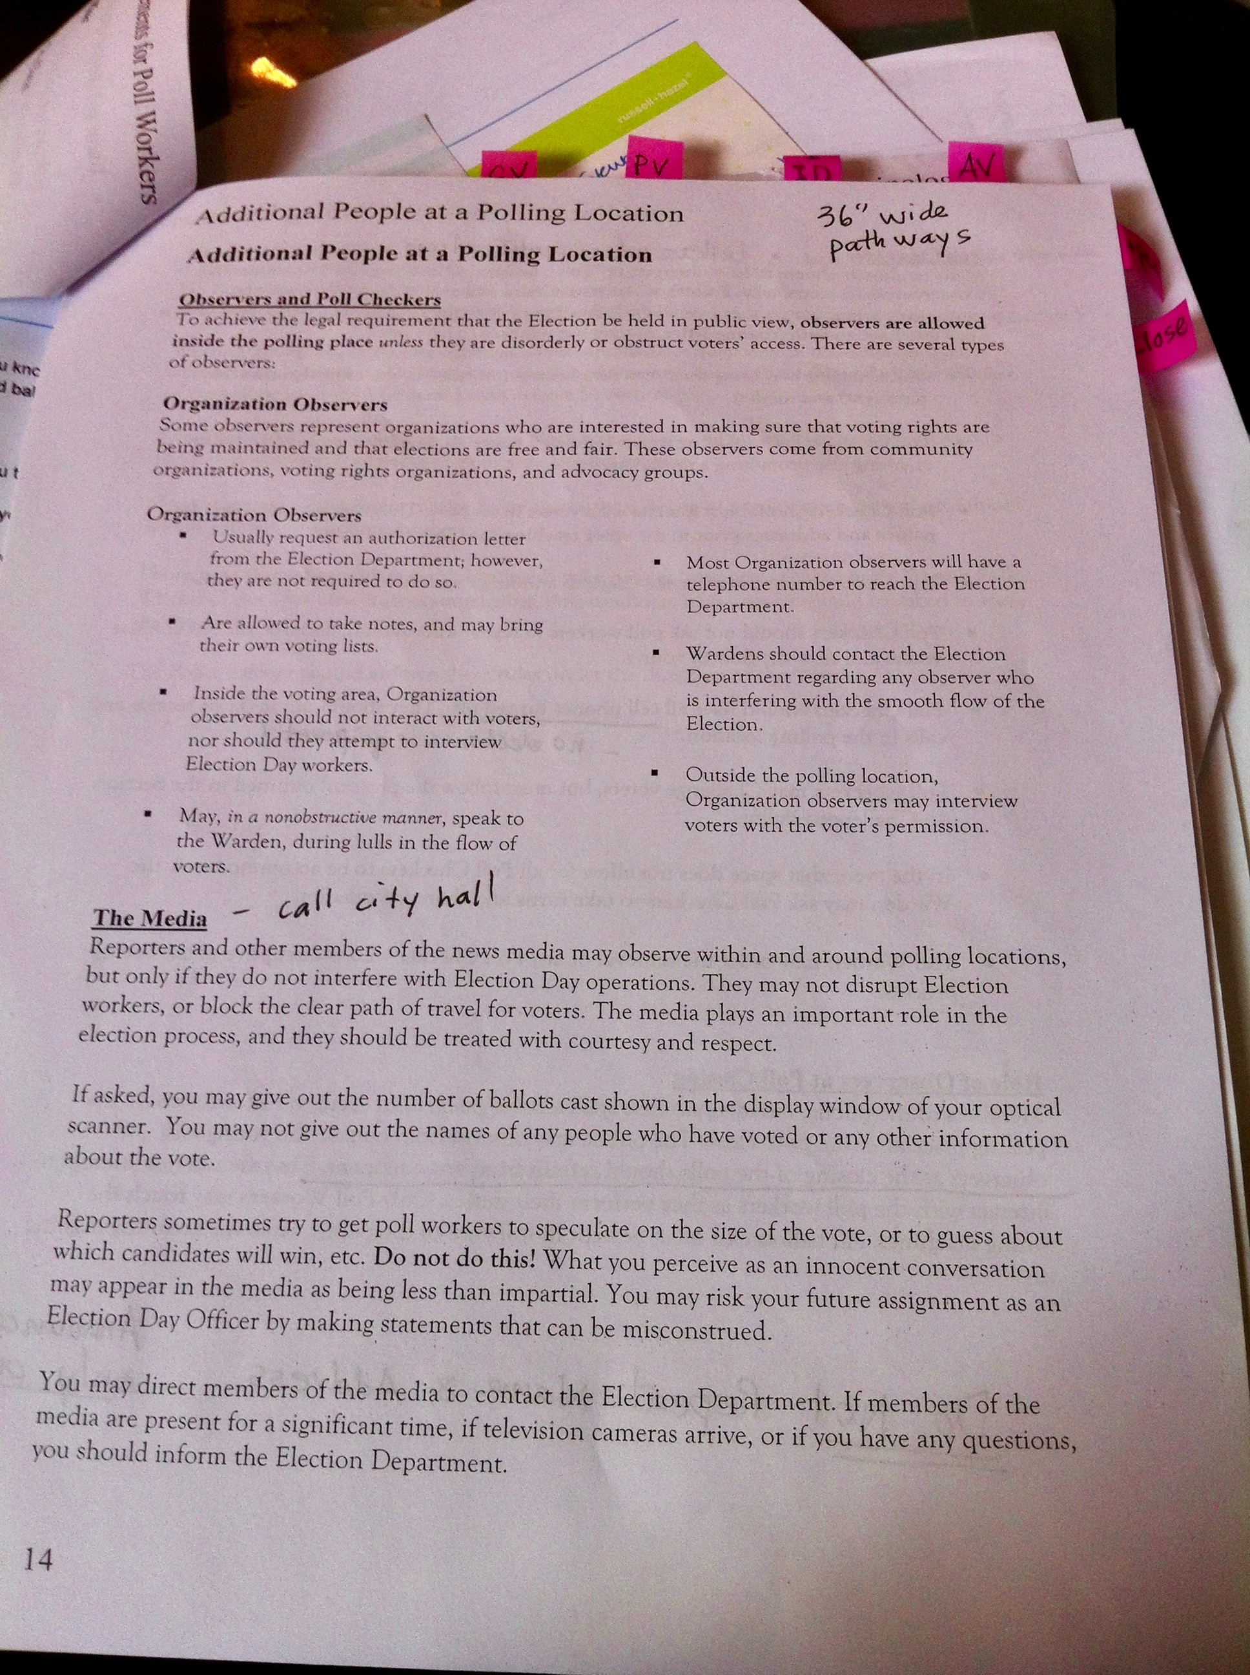 | 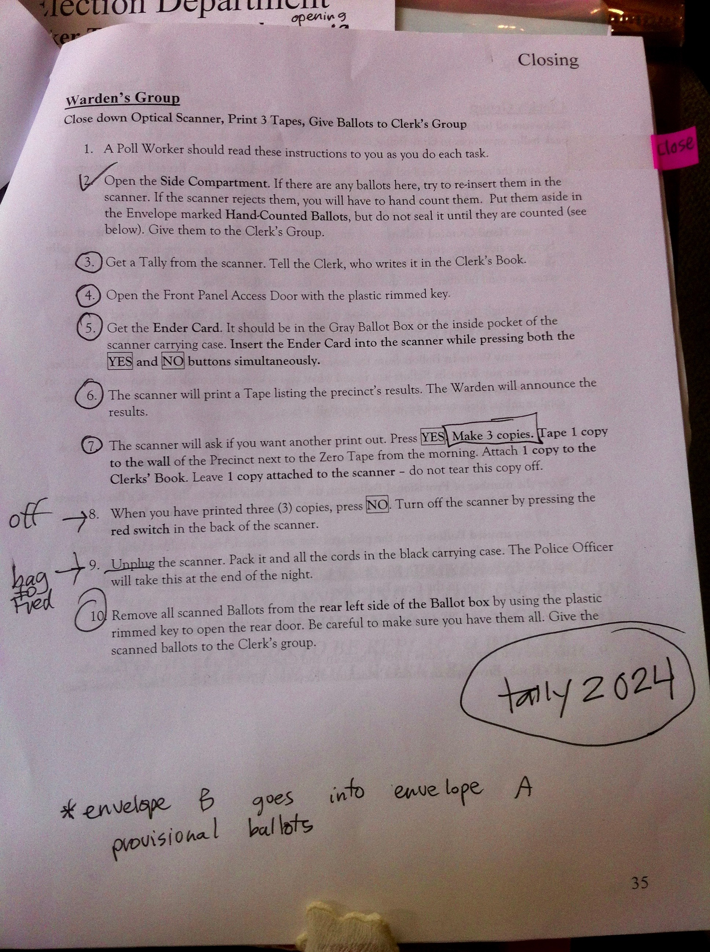 | 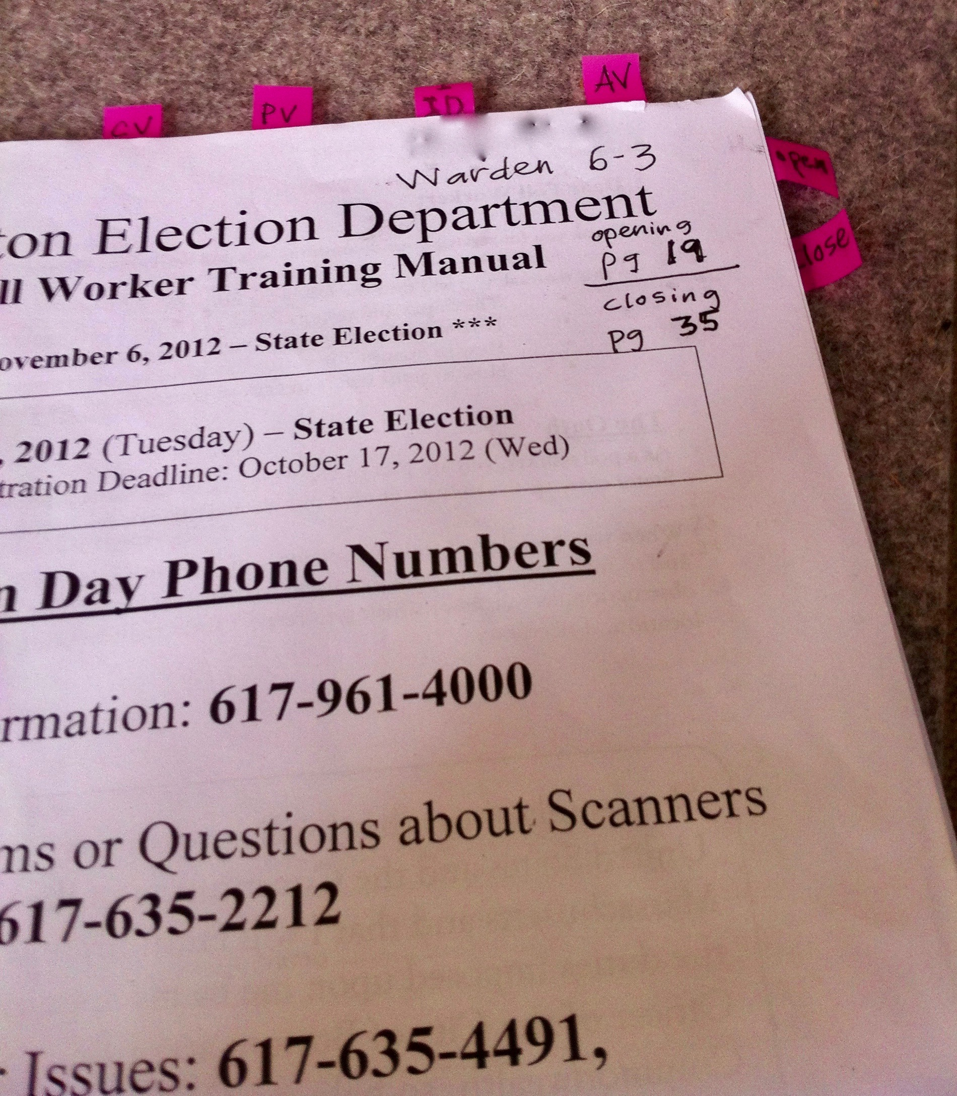
Poll worker manual with tags and notes | Hand-marked procedures suggest use as a checklist | PostIt™ tags with section headings written on them

Our research suggests that the pieces we have created address the Goldilocks Problem and put tools close at hand for workers. While we did not see our designs specifically implemented in the 2018 California primary, we did see that counties had implemented the principles and guidelines we recommend. Workers said they were happy with the support documentation.

Insights from interviews with election administrators
For VCA implementation, we asked election officials about their poll worker training materials, and what changes they were expecting to make because of the switch to vote centers.
They told us they are changing their models for staffing and management because, unlike precinct-based voting, vote center staff must be able to:
- handle a variable, potentially larger, numbers of voters on any given voting day
- issue ballot styles for the entire county
- receive vote-by-mail ballots
- administer conditional voter registration
- work with new and more technology
- be available for working days throughout early voting and election day.
Good management of vote centers includes
- training on operations, procedures, interacting with voters, and managing technology
- day-to-day support of tasks
- managing queues and traffic flow
- troubleshooting
- using the technology efficiently and effectively.
Many California counties have poll worker training manuals that include checklists to help staff on location. Counties anticipated updating and continuing to use checklists as part of their training materials.
Administrators were concerned about technology literacy. Many counties said training on the use of technology would be the biggest change they envisioned between their current practices and what will be required from vote center workers. Some will implement new voting systems, but all counties that are working toward VCA must also implement electronic poll books.
The need for workers who are comfortable using and troubleshooting technology, along with a long early voting period is driving changes in how counties staff their offices and vote centers versus precinct polling. Election workers would also have to understand the procedures for conditional voter registration, and be more mindful of accessibility and language needs.
Recruiting, training, and staffing will be different. Rather than working with one-day paid volunteers, counties told us that they expect workers will be full-time seasonal workers who are supplemented by staff. A few mentioned that they plan to take advantage of county employee sharing programs, where people who are employed in county jobs outside of elections are detailed to elections for the voting period.
Some counties have decided to focus on and train the best of their existing poll worker staff to handle the demands of vote centers. Other counties are looking at hiring retired county workers who have experience managing multiple responsibilities. Some others are exploring a training hierarchy where election leads will train for a longer duration and serve as mentors for temporary and volunteer staff.
County election administrators expected to offer longer training (4-5 hours) that covers the usual procedures for supporting polling, but that also emphasizes technology use, customer service, and making the best decisions for unusual situations.
In our May 2108 visits, we learned that the two counties had developed rigorous hiring processes for vote center workers. One county recruited from their existing pool of experienced, highly rated poll workers. The other county hired people who had never worked the polls before. One challenge for experienced poll workers was to re-learn important processes. For example, moving from conventional provisional voting to conditional voter registration was a complex concept for some.

Differences between precinct-based and vote center administration
To learn the differences between precinct-based polling and polling in vote centers, we conducted several interviews with election officials who either have been running vote centers for some time, or conduct early voting using a vote center model. We also visited and observed in vote centers as elections were being conducted.

Insights
- Election officials who are experienced in running vote centers cross-train their workers in all of the tasks that need to get done in a vote center.
- One of the most efficient ways to run a vote center is for workers to see to all of the needs of a given voter rather than splitting up tasks across different stations. For example, a worker might check a voter in on the voter roll and issue the ballot (rather than issuing a chit to go to a different station to get a ballot).
- Because polling is more automated in vote centers, there are fewer needs for manual checks and reconciliations than for precinct-based, low-tech polling places.
- The tasks and rhythm of a given polling day are similar from Day 1 to Election Day.
- The best-performing election workers are trained through adult learning principles that include scenario- and role-based practice.
- The large manual given out at training acts as backup reference material.
- Sourcing, recruiting, screening, and selecting vote center workers is more like hiring seasonal workers than it is like finding and assigning 1-day precinct-based poll workers.
- Vote center workers will go through a more rigorous vetting process (or be recruited differently) than poll workers.
- Vote center workers will work at least 3 days plus Election Day, and up to 10 days plus Election Day.
- Vote center workers will conduct reconciliations at least daily.
- Some vote centers may need to be completely taken down each night, others will be only partially taken down.

Guidelines
As we started to develop tools for vote center workers, we documented the principles and guidelines we applied.
- Supplement the manual. Don’t expect workers to refer to it. Remove the key items from the loose-leaf binder and put them where workers need them, when they need them.
- Support tasks rather than systems.
- Content and design should support reading to do (rather than reading to learn or reading to learn to do). Vote center worker material should
    - be specific to a role / job
    - be task-based
    - have an easily skimmed visual presentation rather than long prose
- Chunk information into small, modular, role-based, task-based pieces based on when they’ll be needed (setup, versus polling, versus shutdown and closing).
- For checklists, chronological order works best. Split the chronological list by time of day or phase and task. Make each item a clear action to take that can be checked off. For supervisors and leads, include tasks for delegating and giving assignments to the rest of the team.
- Troubleshooting information should be specific to a given station (such as scanners versus check-in) or task (such as supporting unusual voter needs).
- For information about troubleshooting, develop scenarios. Scenarios are situations that vote center workers may face that may be challenging, rare, or nerve wracking. Practice the scenarios in training, and support them in the polling place. Put one scenario on each page or card by itself.
- Help workers use their space in the most efficient way. Use visuals to inventory supplies and equipment. Show images at a size that makes it easy to recognize the item. Show the images laid out in the space from the view of the worker. Make it look like the real setup.

Staffing and training model
The size and resources of the jurisdiction, as well as the configuration of the vote center itself, determine how any of roles listed below might be combined. For example, a supervisor might handle conditional voter registration and provisional voting, and troubleshooting technology issues.
 | Role in the vote center | Tasks
All of these roles might be the same person | Supervisor, assistant supervisor | Oversee setup of the polling place  Manage supplies  Declare the polls open  Manage staff  Manage overall traffic flow  Track performance of staff  Resolve issues  Review logs and verify daily reconciliation  Approve time cards  Process voter challenges  Sign off reports  Declare the polls closed  Media contact
 | Conditional voter registration clerk | Register new voters  Make voter registration changes  Daily reconciliation
 | Provisional voting clerk | Administer affidavit  Issue provisional ballot
These roles might be the same person | Check-in clerk | Set up electronic pollbook  Verify voters against the voter roll  Verify signatures  Generates reports of voters checked in
 | Ballot clerks | Set up ballot station  Inventory blank, printed ballots  Issue ballot cards or issue ballots  Assist with ballot marking device  Daily reconciliation
These optional roles might be the same person | Entry greeter | Assist in setup  Direct newly arriving voters to the correct station  Track wait times  Answer voter questions  Assist in shutdown
 | Exit greeter | Assist in setup  Retrieve ballot definition card from voters (in DRE counties)  Hand out “I voted!” stickers  Assists in closing

There are a few roles and tasks that make it possible for vote center workers to be great – but these people work outside the vote center.
Role – outside vote center | Tasks
Voting equipment support team | Help desk support  On call for troubleshooting in the vote center
Reserve poll workers | On call to substitute for fulltime staff  On call to supplement fulltime staff
Ballot security team | Pick up and drop off ballot boxes
Field reps or rovers (may double as trainers) | Resolve issues with voters  Fill in for workers, if needed  Deliver additional supplies  Take feedback to the election office

Tools for space, tasks, and troubleshooting
To support daily maintenance tasks – planned and unplanned – we developed materials that use small form factors and that are modular. We wanted to give options for how these pieces might be collected or bound together that are inexpensive to make and easy to manage.
We focused on three tools:
- Supplies placemat: a visual inventory of the supplies needed at each station.
- Role-based checklists: role-based checklists tasks divided into times of day.
- Survival guide: flashcards to address exceptional situations.
We designed these tools to be used in vote centers, but they would also work well in precinct-based polling places.

Supplies placemat
The goal of the supplies placemat is to show election workers what supplies they need and when. This tool relies on a library of icons to help workers identify the supplies, tell them where to find each item, and where the supplies go when they need to be used.

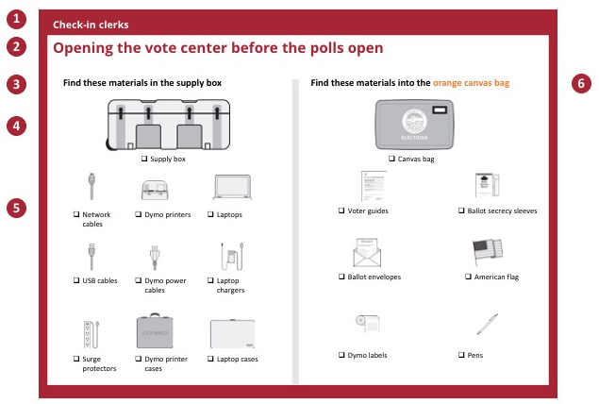
- Include the role for election workers to know they have the placemats meant for them.
- Identify when election workers should use this placemat.
- Provide specific yet concise instructions for where election workers can find supplies.
- Include an icon to show election workers where to find supplies. Show these icons in the order that you expect they will complete this task. For example, in the morning election workers may need to first locate the supply box before needing to know what supplies are in the box. At the end of the day, election workers may need to gather the supplies before putting it in the envelope.
- Fill in the placemat with icons to represent the supplies election workers should find in each box or envelope. Label each icon.
- Place other material packages in their own column.
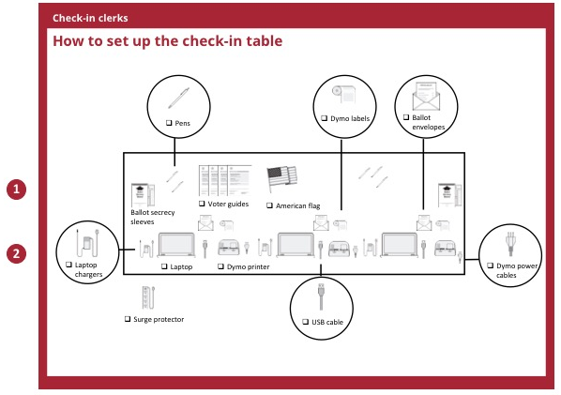
- Include icons to show election workers what supplies they need and suggest how to set it up.
- If images are too small, you can place them as callouts in the circles to “zoom in.”

Role-based checklists
These checklists break the many tasks election workers need to perform into small, manageable pieces. By presenting the content in quarter or half sheet sizes, election workers can carry the checklist as they move around the space. We recommend that you bind the checklist for each role into a booklet.

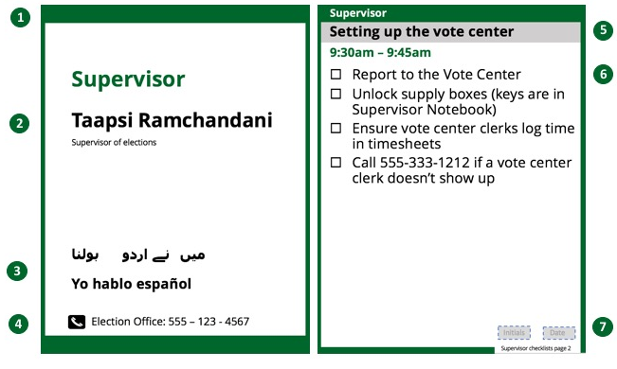
- Use color to indicate role. We’ve assigned colors to roles to help get you started.
- Include your election worker’s name and role on the front page. If attached to a lanyard or otherwise worn, this can double as a nametag.
- Tell your voters who to ask questions or to go to for specific languages.
- Include the Election Office phone number so your election workers (and voters) can easily call in.
- Include a heading for the name of the overall task. You can include specific times that you want election workers to work on tasks.
- Remind election workers what steps they need to complete under that heading. Try to include enough detail so they remember what to do.
- Have election workers sign and date each page to confirm that they completed each task.

Survival Guide Flashcards (troubleshooting scenarios)
No matter how much you plan, unexpected events or questions arise. These flashcards can help election workers know how to respond to the unexpected.
Questions and answers get divided into categories: voters and workers, technology, and operations. You can add more categories as you see fit. Use these cards during training to help election workers prepare for Election Day. They are great for scenario training.
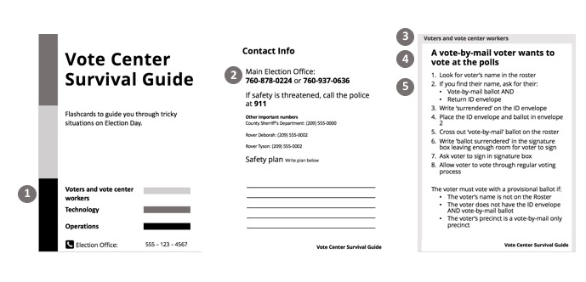
- To avoid confusion, we use shades of gray to indicate the different categories of the survival guide. Here are 3 different shades to get you started. You can add or modify the categories for your own use in the master slides. Notice that these are the same shades as the border of each individual card.
- Use the second page of the survival guide to include any contact information or other details that your election workers need to know in a flash.
- Match the borders of each card to the category it belongs. Also write the category as the top heading.
- State the problem as a heading. Make this big and concise so election workers don’t have to search to find what they need.
- Include action steps to tell election workers how to respond to the situation.

