Design Documentation
Vote-by-Mail Envelope Design
for California
December 15, 2017

In 2018, the first counties in California will start the transition to a new elections model under the Voter’s Choice Act, in which all voters will receive their ballots by mail, with options to return them by mail or dropbox, or they can choose to vote in person.
To help prepare for this transition, the Center for Civic Design has worked with the California Secretary of State’s office, county election offices, and national experts to design templates for the vote-by-mail packages, including the envelopes sent out by the local election offices, the ballot return packages, and the instructions for voters.
The goals for the design
The goal of this project is to create materials that can be used in any county, whether it is implementing the full Voter’s Choice Act or not. A consistent design for vote-by-mail will help election offices and advocacy groups help voters identify and use vote-by-mail more effectively. It is also a fresh design to go along with a new voting model.
This design is intended to be a flexible template, providing consistency and a logical layout, while allowing for variations based on the size and layout of different envelope styles and election management systems.
Another important goal is a vote-by-mail package that even new voters, voters with low literacy, or voters with low civic literacy can use accurately, to reduce the number of ballots that cannot be counted or require corrections.
A successful design will make it easier for voters to vote by mail, within affordable and robust election administration. The design must work for all stakeholders:
- Make it easier for voters to recognize and return their ballot accurately, with clear, effective instructions.
- Support bilingual ballots to meet Voting Rights Act language access requirements, while still making the envelopes easy to read and use.
- Improve election administration by creating materials that reduce errors and make it easier to process vote-by-mail ballots.
- Support a statewide voter education campaign about how to vote by mail, by creating recognizable consistency across the state.
- Support local election offices with flexibility to customize the templates to local information and their procedures and systems for handling vote-by-mail materials.
- Support accurate handling and delivery of ballots sent through the US Postal Service (USPS).
What’s in the design?
The design includes:
- A logical arrangement of the content elements that can be adapted to different envelope systems.
- A layout that can adapt to different size envelopes, within a reasonable range of sizes in common use.
- Sample text for the envelopes and instructional inserts that can be customized to the needs of each county.
- Guidelines for how color can be used consistently and meaningfully to support easy identification of the envelopes and specifications.
- Sample instruction inserts.

Table of Contents
Envelope layouts 4
Outgoing envelope front 4
Outgoing envelope back 5
Return envelope front 6
Return envelope back with overprinting 7
Using colors to identify ballot types and counties 8
Vote-by-mail color palette 9
Description of the elements on the envelopes 10
Postal and Election Mail requirements 10
Identification as an official vote-by-mail envelope 13
Signatures and other forms 14
Voter’s declaration and warnings 17
Final checklist and reminders 18
Instructions on the envelope 19
Envelope structural elements 20
Instructions insert or secrecy sleeve 21
Ballot secrecy and signature security 23
List of elements on the envelopes 24
How we ran this project 25
Sources for requirements 26

Envelope layouts

Outgoing envelope front
Layout designed for 9.5” x 6.5” envelopes

Outgoing envelope back
Layout designed for 9.5” x 6.5” envelopes

Return envelope front
Layout designed for 9” x 6” envelopes

Return envelope back with overprinting
Layout designed for 9” x 6” envelopes. Text under the flap not shown in this view

Using colors to identify ballot types and counties
The colors of the envelopes help voters and election administrators identify different types of ballot envelopes easily. The colors are also helpful for the USPS, because they help distinguish envelopes on their way to voters from those returning to the elections office. The color wraps around the edge of the envelope so it is visible in a stack of mailers making them easy to identify at the postal facility. [4]
- All outgoing envelopes use the same color, a medium blue.
- The standard color for return envelopes is a dark green.
There are also 7 alternative colors (3 additional colors and 4 lighter variations) that can be used for overlapping special elections return envelopes, to differentiate neighboring counties, or (for non-VCA counties) to identify all VBM districts vs. voters who have chosen vote-by-mail.
- UOCAVA return envelopes use brown or an alternative lighter tan.
- Provisional ballots use pink. CVR provisional ballots use yellow.

Example of how colors might be used in two neighboring counties

Vote-by-mail color palette
The envelope colors meet accessibility requirements for large white text. The dark colors meet WCAG 2.0 Level AAA at 7:1 contrast. The lighter colors meet Level AA at 4.5:1 contrast. The provisional envelope colors have greater than 10:1 contrast with black text.

Color specifications
Envelope Type | Color | Sample | Hex | RGB | CYMK
Outgoing | Blue |  | #00607a | 0, 96, 112 | 100, 50, 0, 23
Return | Green |  | #00662b | 0, 102, 43 | 90, 0 100 50
Alternates | Lighter Green |  | #318241 | 64, 142, 97 | 68, 0, 75, 38
 | Purple |  | #624c91 | 99, 77, 145 | 65, 75, 0, 15
 | Lighter Purple |  | #7e6da6 | 138,121,173 | 49, 56, 0, 11
 | Teal |  | #006071 | 0, 96, 123 | 100, 40, 30, 29
 | Lighter Teal |  | #005f7a | 64, 136, 155 | 75, 20 22, 21
 | Grey |  | #4c4c4e | 77, 77, 79 | 0, 0, 0, 85
 | Lighter Grey |  | #797a7d | 121, 121m 123 | 0, 0, 0, 64
Provisional | Pink |  | #f6acbb | 249, 193, 205 | 0, 30, 8, 0
CVR Provis. | Yellow |  | #ffd88f | 355, 226, 171 | 0, 11. 38, 0

Description of the elements on the envelopes

Postal and Election Mail requirements
Outgoing envelope  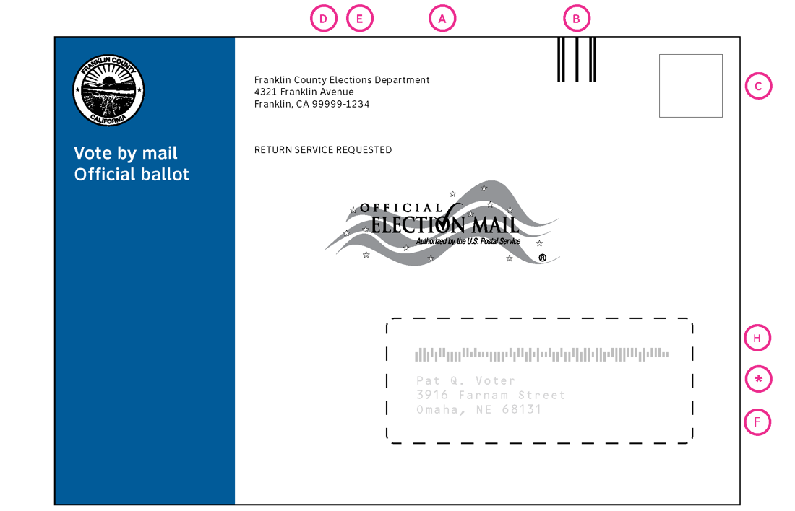  Return envelope (top) | (A) Election mail logo  (B) Facing Identification Mark (FIM)  (C) Postage Paid or Postage instructions  (D) County return address  (E) Return service requested notice  (*/F) Voter’s mailing address (and window on the outgoing envelope)  (G) Election office mailing address (on return envelope front)  (H) Intelligent Mail Barcode (IMB)  In this design the USPS “addressing area” is the space to the right of the colored area.

This section includes all of the elements needed to accurately send the envelopes through the US Postal Service. When designing an envelope, please consult the postal manuals to be sure you understand the entire requirement. [3]

Election Mail logo
See USPS Pub 631 for information about the election mail logo.
- Follow requirements for clear space required around the logo.
- Be sure to use the correct size of the logo -most vote-by-mail envelopes will use the medium size.

Facing Identification Marks (FIM)
Follow USPS specifications for spacing and placement of these marks, which are used to help the automation equipment find the front of the envelope.

Postage Paid or Postage instructions
Follow USPS regulations for the postage block in the upper right corner.
- Text must be a minimum of 8 points.
Research with low-literacy, low civic engagement voters in inner city Baltimore suggests that the instruction “Postage Required. Post Office will not deliver without proper postage” is more effective if placed below an empty rectangle because participants interpreted anything except an empty box to be postage-paid mail. [7]

Election office return address
See USPS DMM-603 for addressing instructions.
- The election office return address on the outgoing envelope must match the postal permit number used for postage. Be sure to include the full ZIP+4.
- For return envelopes that are “Courtesy Return” (that is, not postage-paid return), USPS requires that there be a place for a return address.
- The layout leaves a blank space on the return envelope corresponding to the location of the election office return address on the outgoing envelope. Some mailing specialists suggest including 3 blank lines for the voter to write a return address. (USPS 703.82.5)

Ancillary Service Endorsements
See USPS Pub 507d for return service or address service requests.
- There are 4 possible locations for this text, with the space under the return address the least confusing on the crowded outgoing ballot.
- An endorsement must be at least 8-point type in all capital letters. It must stand out clearly against the background and have ¼” clear space on all sides.

Intelligent Mail Barcode (IMB)
See IMB details and guidelines at https://ribbs.usps.gov.
- The Intelligent Mail Barcodes (IMB) support the USPS Intelligent Mail Services, including tracking mail pieces.

Mailing addresses
- The election office mailing address is printed on the front of the return envelope, with the associated IMB code.
- The voter’s outgoing mailing address is either printed on the back of the return envelope and shows through a window in the outgoing envelope, or can be printed on the outgoing envelope.

An open issue: the voter’s outgoing mailing address
The location and treatment of the voter’s outgoing mailing address is still an open issue. Election departments want to print it on the back of the return envelope so it shows through a window in the outgoing envelope. This allows all of the information for each voter to be printed on one envelope, eliminating the challenge of synchronizing two envelopes and the ballot types.
However, during the 2016 election, some returned envelopes were delivered back to the voter, when postal automation equipment read the voter’s address and IMB as the destination. The USPS is still testing possible solutions to this issue.
Suggested solutions being tested include:
- Placing two duplicate IMB above and below the elections office mailing address on the front of the return envelope. This may increase the algorithmic “weight” of that side of the envelope for the automation equipment. [3]
- Place an IMB for the elections office in the lower right corner of the back of the return envelope, where it is hidden below the window on the outgoing envelope, but visible for the automation equipment during the return trip. [13]

Please consult your election mail specialist before finalizing your envelope layout.

Identification as an official vote-by-mail envelope
Outgoing envelope Return envelope | Identification as an official ballot  (I) County seal [8]  (J) Official ballot notice [1 - a.5]  (K) Envelope type (return envelope)  (L) Canvassing board notice (return envelope) [1 - a.5]  (W) Deadlines  (ø) Colored area
Back of the return envelope  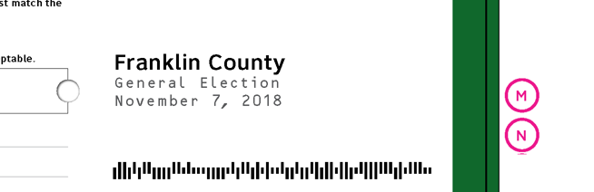 | Identification of the county and election  (M) The name of the county [13]  (N) The name and date of the election [13]

Official ballot identification and canvassing board notice
In the colored area, the county seal and text identify the envelope and what it holds.
- The county seal or other official logo appears on all envelopes. Although voters might not identify a specific county seal, they do see seals, in general, as a sign of official information. It will also help election workers differentiate between envelopes from their county or another one.
- Both outgoing and return envelopes include notice that the envelope contains an official ballot.
- The Return Envelope is named in the identification so it can be matched to instructions, making it easier for voters to understand which envelope to use.
- The return envelope includes a notice that the returned ballot is to be opened only by the canvassing board.

Deadlines for returning the ballot by mail or by dropping it off
- The deadlines for returning the ballot are included so that this critical information is available to the voter on the envelope itself.
During usability testing of the prototypes, voters wanted this text as large as would fit on the envelope easily. [14]

Identification of the county and the election
- Printing the name of the county on the back of the return envelope is helpful for election administration, so that a worker looking only at the back of the envelope can easily identify ballots from another county

Signatures and other forms
California Elections Code 3011 and 354 [1] require several different signatures on the ballot return envelope. This section includes all of the additional forms the voter may need to complete signing and sealing the envelope. The layout also includes related design elements that help make the envelopes easier to use.
All of these elements are on the back of the return envelope so that someone examining the envelope can see them all at the same time.

The most important of these forms is the area for the voter’s signature and related information.
To the extent possible with different envelope styles, the location of the signature on the return envelope should be as consistent as possible, so that statewide voter education can accurately portray the location. [5]
Even if the signature area moves so that it can be placed appropriately around the envelope flap or below a peel-away tab that hides the voter signature, the signature area should be consistently placed below the voter’s declaration.

Voter signature area with witness signature
Blank signature form  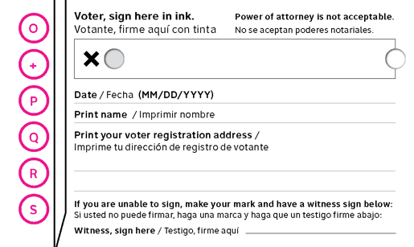  Form with voter information printed  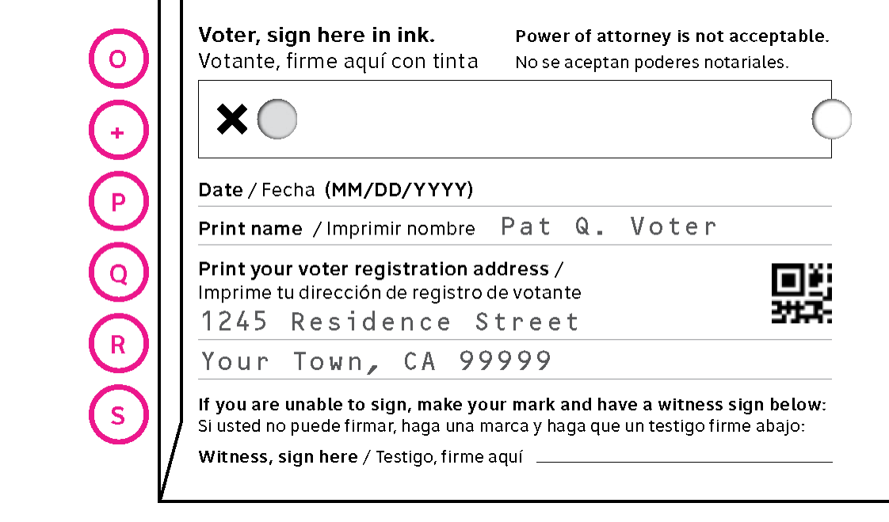 | (O) Voter’s signature [1-a.2]  (P) The date of signing [1-a.4]  (Q) Voter’s name and registration address [1-a.3]  (R) Voter scan code for the election management system [13]  (S) A witness to a mark in place of a signature [354.5]  (+) Holes to identify the signature area [12]

Voter’s signature and address
The voter’s signature block includes several elements, arranged in a consistent layout.
- The area for the voter’s signature is enclosed in a rectangle, with a large X inside. This makes it visually distinct, and encourages voters to sign within the space provided. This also helps with signature verification for both manual and automated systems. No other signature on the envelope should have this mark or be enclosed in a box. [4, 9, 10]
- The title for this area is an instruction, “Voter: sign here in ink,” placed just above the signature box, with “Power of attorney not acceptable” in small type on the same line or just below it. [4, 9, 10]
During usability testing of the prototypes, voters asked whether they had to sign in ink. They wanted confirmation that they had all the details right. [14]

- Punched holes around the signature area can serve as guides to help blind or low literacy voters sign accurately
The two holes help blind voters to tactilely identify the location of the signature space and the correct orientation of the envelope. One goes all the way through the envelope, one only through the front or back. [12]

Blank or pre-printed form
The form for the voter’s name, and address can be left blank, to be filled in by the voter, or can be printed on the envelope as part of the addressing process.
- When a name must be printed, include that information in the prompt, making it a clearer direction. [4, 10, 14]
- Printing the name helps avoid spousal swaps (when family members return their ballot in the other’s envelope). This causes problems when the wrong voter is “checked in” as having returned a ballot. [4]
- Preprinting the voter’s registration address (rather than the address for their vote-by-mail ballot) on the envelope helps low literacy and low civic literacy voters comply with this requirement for accepting a vote-by-mail ballot.
- Some counties also print a small code that can be scanned to bring up the voter’s record in the EMS.

Witness signature area
A witness to the signature is required for voters who only make a mark.
- This signature should be placed on a line (not in a box) so that it does not compete with the critical voter signature.
During usability testing of the prototypes, voters were confused about whose name to write and who should sign when the prompt just said “Name” [14]

Bearer name and signature
Back of the return envelope  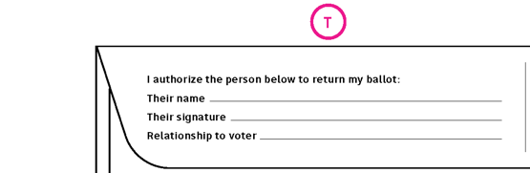 | (T) Bearer’s name and signature [1-a.9, 10, 11]

California law requires that if someone other than the voter returns a vote-by-mail ballot, they must be identified. This section of the code was amended in 2017 to allow any person, not just those with a list of specific relationships.
- The name, relationship, and signature of a person authorized to return a ballot for a voter is in a small form on the outside flap of the envelope.
In usability testing the prototype, voters were confused about whose name and signature was needed, so the prompt was changed to say “Their name” and “Their signature” to clearly identify who should sign. [14]

- The name and date of the election is helpful to ensure that only envelopes with voter information for the current election are used. It is also useful in the case of overlapping special elections. It is also on the back of the return envelope with other active elements.

Voter’s declaration and warnings
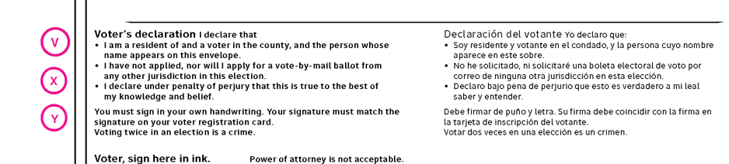 | (V) Voter’s Declaration (1-a.1, 8)  (X) Signature warning (1-a.6)  (Y) Voting twice warning (1-a.7)

The voter’s declaration includes several sections:
- A declaration, under penalty of perjury, stating that the voter resides within the precinct in which he or she is voting and is the person whose name appears on the envelope. (a.1)
- A statement that the voter has neither applied, nor intends to apply, for a vote by mail voter’s ballot from any other jurisdiction for the same election (a.8)
- A warning that the voter must sign the envelope in his or her own handwriting and that it must match the voter registration signature for the ballot to be counted. (a.7)
- A warning that voting twice is a crime. (a.6)

Final checklist and reminders
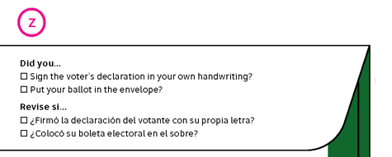 | (Z) “Before you seal” checklist
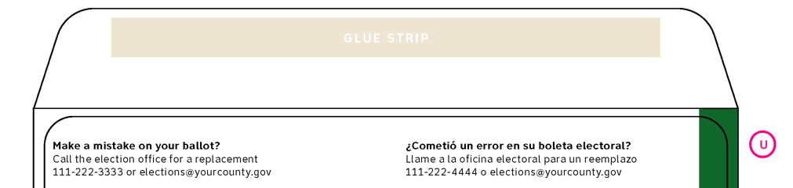 | (U) How to get a replacement ballot

A final checklist, placed so that it is visible as the envelope is sealed reminds voters to:
- Sign the voter’s declaration
- Put their ballot in the envelope
In Shasta County, some voters checked off items in the instructions and the final checklist, showing that they had seen and used this information. [11]

Other helpful reminders include how to correct a mistake on the ballot. This information can be in the instructions insert in more detail, but should also be on the ballot.
- How to get a replacement ballot [13]

Instructions on the envelope
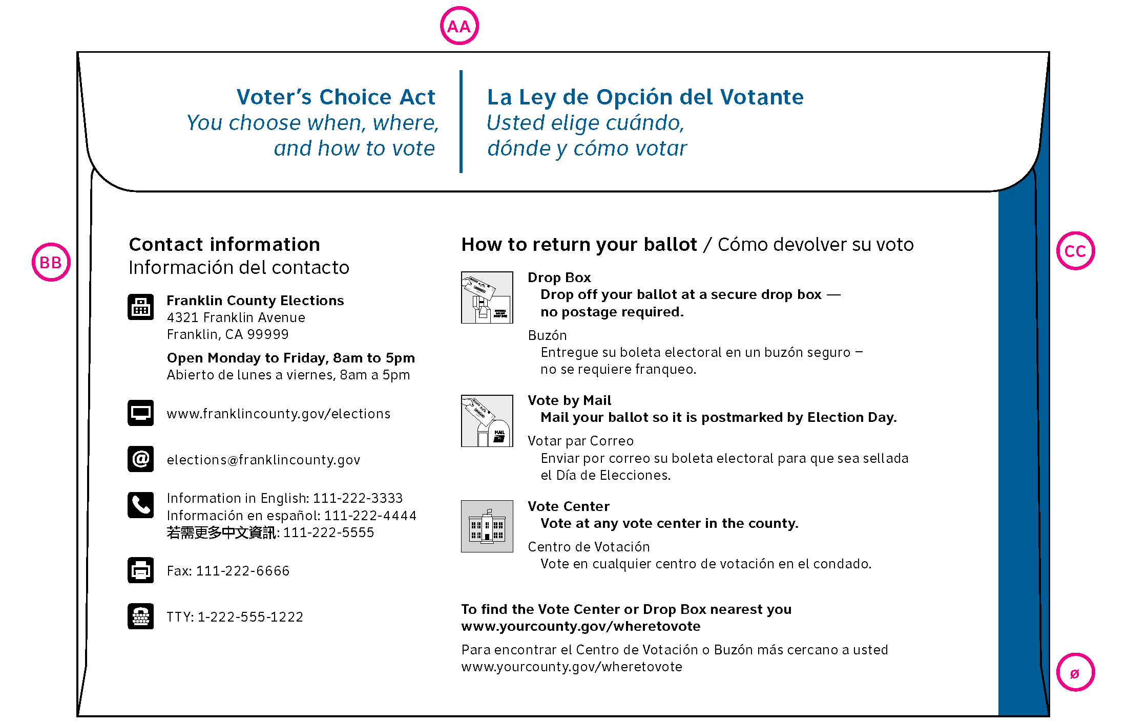 | (AA) Message area  (BB) Contact information  (CC) How to return the ballot
The outgoing envelope has room on the back for instructions or other helpful information

Message area
- The back flap of the outgoing envelope can be used for a message. This area can call attention to anything new in the election – such as the Voter’s Choice Act

Contact information
- The contact information should include all of the ways to communicate with the elections office, including information in any languages the office supports.

Summary of how to return the ballot
The other area for instructions is an overview of how to return the ballot.
- The information is tailored to each county and the options available.
- Include a link to find a list of drop boxes, polling places, and vote centers.
- Bilingual envelopes have a shorter version to allow both languages to fit.
- Both versions use icons to illustrate each option.

Envelope structural elements
Some features are built into the envelope, rather than printed on it. When these features are used, the layout of the other elements may need to shift to fit the envelope dimensions.
- The bottom of an address window should be at least ¾ of an inch from the bottom of the envelope to ensure the stability of the envelope.
- A punched hole in the return envelope shows election workers if a ballot is in the envelope without opening it. This hole might be part of the pair of holes surrounding the voter’s signature area as a guide.
- Some outgoing envelopes have a small window positioned to make it easy to check that the correct ballot type has been inserted into each envelope.
- Using a signature privacy tab means that the signature area must be positioned under the flap of the return envelope
- Any colored area that wraps to the back of the envelope must be narrow enough that it does not interfere with the USPS clear space around the address or automation features. A maximum of ½” is a good starting rule of thumb.
- The size of the return envelope should allow voters to easily fit all of the materials (including ballot and secrecy sleeve, if used).

In the VSAP study, when the fit was too tight, participants worried that the envelope would “not stay safely sealed in the mail.” [6]

Instructions insert or secrecy sleeve
To support voters, the design includes a voter guide insert with detailed instructions, appropriate to whether the county has implemented the Voter’s Choice Act. These inserts give voters complete, clear, plain language instructions included with in the ballot package that walks through the entire process from marking the ballot to returning it.
The instructions include:
- The process for voting, including reminding voters to return their ballot [5,7, 8]
- A list of options for returning the ballot, including drop boxes [4, 13]
- A way to find the location anywhere to return a vote-by-mail ballot [4, 12]
- Instructions for Remote Accessible Vote by Mail, if available [4 13]
- The deadline for returning ballots and any related requirements [1, 4, 13]
Some counties use a secrecy sleeve so the ballot is protected while the ballot is being opened. Instructions for marking the ballot can be printed on the secrecy sleeve. Final instructions for signing the return envelope and returning the envelope, however, should be on an insert that is not returned with the ballot.
In usability testing in Baltimore, participants had less trouble understanding how to pack their ballot when an inner envelope or secrecy sleeve was distinct in size and appearance from the mailing envelope. [7]

Good practice for packing the envelopes is to pack the ballot inside any instruction insert or a secrecy sleeve so voters notice it. [6, 7]

Sample inserts
The sample inserts in a half-page brochure
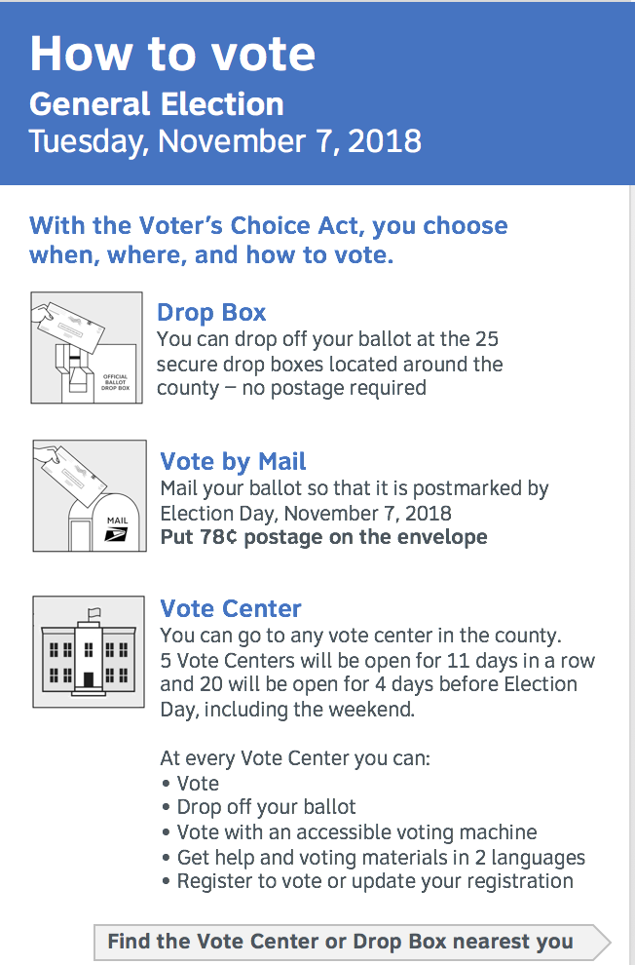 | 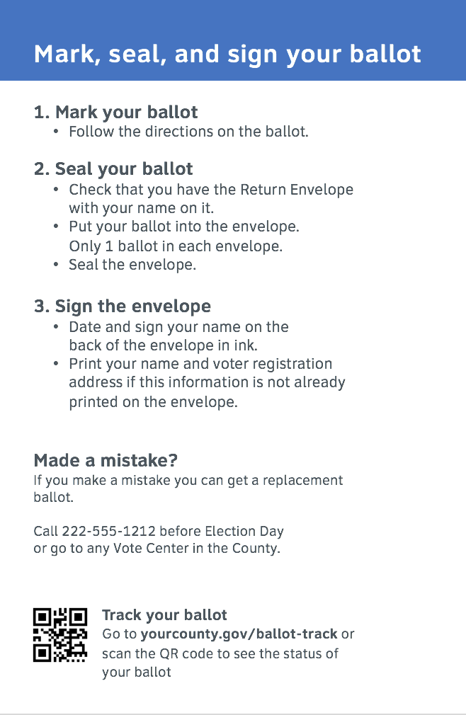 | 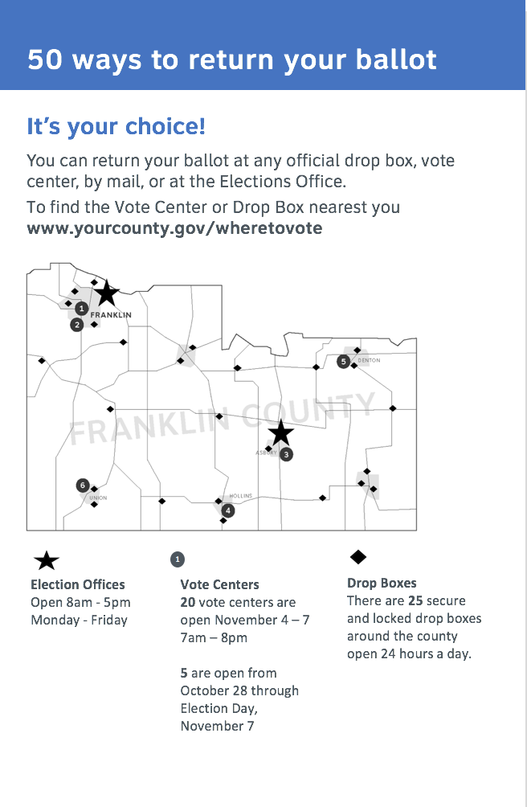 | 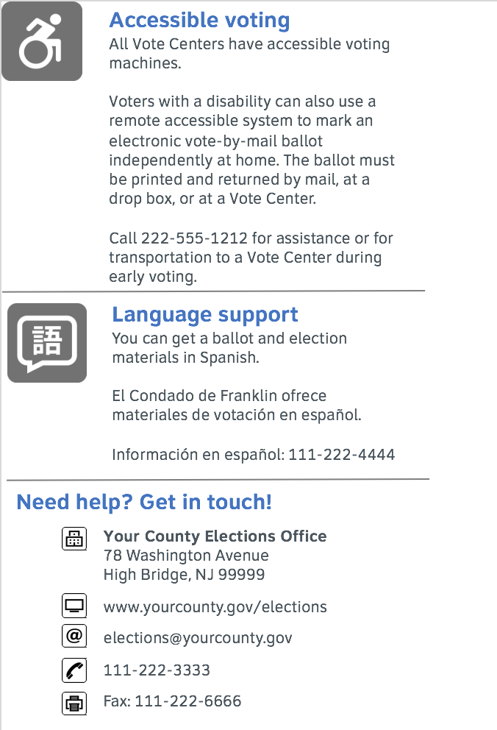
Cover  How to vote  Election name and date  Options for returning the ballot  Information about polling places or vote centers | Inside left  Mark, seal, and sign your ballot  Instructions for voting  How to get a replacement ballot  How to track your ballot | Inside right  50 ways to return your ballot  Information about options and hours  Map to show range of locations | Back  Accessible voting  Accessible voting machines  Accessible remote voting (if available)  Language support  Contact information

The sample insert is available online as a PowerPoint file in three versions:
- English version for the Voter’s Choice Act counties
- Spanish version for the Voter’s Choice Act counties
- English version for other counties
The translations files are also available. The translations were made by CTS Language Link, but have not been verified.

Ballot secrecy and signature security
There is a wide variety of designs for how ballot secrecy is protected and whether signatures are hidden or exposed on the return envelope.
Although election officials do not report many issues with exposed signatures, in an age of increasing identify theft, hiding the voter’s signature might be an issue in the future.
There is some evidence that voters, especially in cities, do not trust street-corner mailboxes as safe or secure [7, 11]. Officials in other all-vote-by-mail states report that a significant majority of ballots are returned using drop-boxes or other election office. This may be motivated by the desire to return the ballot directly to an arm of the election office, concerns about USPS reliability, concerns about protecting their personal information, or a mix of all of these issues.

Hiding the signature
There are several envelope designs that hide the signature in use. They include:
- Large envelope flaps that cover the entire form with the voter’s signature and address. Typically the flap can be opened without opening the part of the envelope holding the ballot, so the ballot remains secret until the voter is authenticated.
- Rolled envelope flaps, which are folded twice to hide the signature. Like the large flaps, the main compartment of the envelope is opened separately.
- Signature windows or small sections of the envelope that are torn away to reveal the signature.
These designs, however, have an impact on election administration processes, as almost all of them require the envelope to be handled twice: once to reveal the signature so the voter can be authenticated, and a second time to open the envelope and extract the ballot.

Other ballot security or privacy solutions
- In addition, some counties position the signature block so the voter signs over the sealed flap, making tampering easier to detect.
- Some counties include a secrecy sleeve. This is a paper folder open on two sides, which protects the ballot from casual visual inspection as the envelope is opened.

List of elements on the envelopes
ID | Name | Used on
Postal and mailing elements
A | Election Mail logo | Outgoing, Return
B | FIM | Outgoing, Return
C | USPS Postage | Outgoing, Return
D | County return address | Outgoing
E | Return service requested | Outgoing
F | Voter’s mailing address | Return
G | Election office mailing address | Return
H | Intelligent Mail Barcode (IMB) | Outgoing (voter), Return (office)
Elements to identify the envelope or election
I | County seal | All
J | Official VBM notice | Outgoing, Return
K | Envelope type | Return
L | Canvassing board notice | Return
M | Name of county | Return
N | Name and date of election | Return
ø | Colored area | All
Voter’s signature and other forms
O | Voter’s signature | Return
P | Date of signing | Return
Q | Voter’s name and registration address | Return
R | Voter’s EMS scan code | Return
S | Witness signature | Return
T | Bearer’s name and signature | Return
Voter’s declaration and other notices and reminders
V | Voter’s declaration | Return
W | Election deadline notice | Return
X | Signature must match | Return
Y | Voting twice is a crime | Return
Z | Before you seal checklist | Return
Instructions
AA | Promotional area | Outgoing
BB | Contact info for elections office | Outgoing
CC | How to return instructions | Outgoing
Structural elements on the envelope
* | Window to show voter’s address | Outgoing
+ | Holes to identify the signature area | Return

How we ran this project
The design guidelines are drawn from the Center’s experience testing a variety of election materials, including vote-by-mail envelopes in Baltimore and Shasta County, voter registration forms, other election forms, and usability testing of design prototypes, as well as from the experience and wisdom of the election officials who have worked on this project with us.
Preparation for the project included:
- Review and analysis of the contents and format current vote-by-mail envelopes from all California counties, collected by the Secretary of State’s office.
- Review of the California Election Code requirements for information and forms on vote-by-mail return envelopes.
- Review of US Postal Service requirements for election mail.
- Review of best practices in vote-by-mail designs from other states.
- Review of recent research on vote-by-mail design and work conducted for the Voting System Assessment Project.
Feedback during the project included several sources:
- Review and feedback from California election officials and the Secretary of State’s office.
- Review and feedback from the USPS Election Mail unit and other experts on election mail, including Tammy Patrick.
- Usability testing with voters in Calaveras, Santa Cruz, Shasta, and Tuolumne counties, including review of the returned envelopes by election officials in those states.
We created sample envelopes:
- We used the most common size in the collection of envelopes in use in California— 9.5” x 6.5” outgoing envelopes and 9” x 6” return envelopes.
- The first set included outgoing and return envelopes in English and bilingual English and Spanish. After usability testing the bilingual return envelopes were reprinted with corrections.

Sources for requirements
Election officials suggested many of the requirements during our interviews. Other sources that either confirmed that input or added specific details based on policy or research are listed here.
- California Elections Code Section 3011 and 354
- USPS Publications (including Pub 631 Official Election Mail—Graphic Guidelines)
- USPS presentations to the EAC Standards Board, CACEO, and other conferences
- Presentations or personal communication with Tammy Patrick (Presidential Commission on Election Administration and postal election mail expert)
- California Secretary of State’s Office presentations or personal communication
- “Vote-by-Mail Research Report” – LA County VSAP and IDEO, March 2016
- “Making Voting by Mail Usable, Accessible, and Inclusive” – Kathryn Summers, Whitney Quesenbery, Amy Pointer, paper at AHFE 2016
- “Best Practices for Official Voter Guides” – Center for Civic Design and League of Women Voters of California
- Showcase: Absentee Ballot Instructions in Minnesota – Center for Civic Design and Minnesota Secretary of State’s Office
- Showcase: Voter registration forms in Pennsylvania (and others) – Center for Civic Design and Pennsylvania Secretary of State’s Office
- Usability testing vote-by-mail envelopes in Shasta County (2015)
- Oregon vote-by-mail accessible envelope design
- Feedback from California elections officials or mailing specialists
- Usability testing for this project with voters in Calaveras, Santa Cruz, Shasta, and Tuolumne Counties (November 2017)

Download this report
You can download a copy of this report and all sample files for envelope layouts and inserts from:
https://www.civicdesign.org/projects/vote-by-mail

For more information
If you would like more information about this project, or help using these designs to update your vote-by-mail envelopes, we’d love to talk to you:

Center for Civic Design
www.civicdesign.org
hello@civicdesign.org
410-921-6811

