Text Size Requirements Recommendations for VVSG 2.0
A white paper for the EAC-NIST Human Factors Public Working Group
Center for Civic Design - Whitney Quesenbery, Dana Chisnell
University of Baltimore - Kathryn Summers
Michigan State University UARC - Sarah Swierenga, Graham Pierce, Jennifer Ismirle
Draft: September 12, 2016
Distributed to the Working Group: October 25, 2016
This brief white paper looks at voting system requirements for text size and options for voters, comparing the current VVSG 1.1 requirements with more recent research evidence and making recommendations for how the VVSG might be updated.

Current VVSG 1.1 requirement
See the full text of the current requirements at the end of this white paper.
See an explanation of how text size is measured and examples of different font sizes
3.2.5 Visual display characteristics
The requirements of this section are designed to minimize perceptual difficulties for the voter.
d. For all text intended for voters or poll workers, the voting system shall provide a font with the following characteristics [capital letter height, x-height, stroke width]
e. A voting system that uses an electronic image display shall be capable of showing all information in at least two font sizes: [3.0-4.0 mm cap height, and 6.3-9.0 cap height].
The system shall allow the voter to adjust font size throughout the voting session while preserving the current votes.
f. Text intended for the voter should be presented in a sans serif font.
3.3.2 Enhanced visual interfaces
This section requires synchronous audio and visual displays, then refers to 3.2.5.

Why these requirements need updating
Since 2005, there is a substantial new body of evidence that the current sizes are simply not large enough. Some of the limitations on the text size in VVSG 1.1 were based on the challenge of making printed ballots with large text, especially for creating a Voter Verified Paper Audit Trail (VVPAT) printout on narrow paper.
Minimum font sizes on printed ballots are still useful, as evidenced by complaints (in New York City, for example) that the ballots were unreadably small. However, electronic interfaces offer more ability to adjust the size of the screen presentation, so this paper is primarily focused on electronic displays
The challenge in updating these requirements is to find a range of sizes that meets two needs:
- Making it easier for more voters to read the ballot without special assistive technology (or, in some cases, ensure that they can read it at all).
- Ensuring that size is not so large that it forces distortions in the ballot layout causing possible errors in how voters mark their ballot. These effects might include breaking the consistent relationship between candidate names and the marking mechanism.

Updating the VVSG to use larger text sizes has an impact on the requirements about navigating within a contest (the topic of a related white paper).

What should the VVSG say?
Overall, the research (see below) indicates that the text should be larger, making it possible for more people to comfortably read the default size, and offering a wider range of options for larger text.
- The required text sizes should be keyed to the size of the candidate names, allowing for a visual hierarchy of information including (slightly) smaller secondary text and larger titles or headings.
- The entire interface should zoom with the text size, so that text on buttons or other navigation elements also increases or decreases in size, proportionately.

Any text size requirements will also have to take into consideration the type of device and the posture in which it is typically used. A screen used in a kiosk (standing or sitting) typically has a larger viewing distance than a hand-held tablet or small mobile device. There also might be more leeway for the text size on a ballot marking system using a voter’s personal device than one in which the system includes the hardware and sets the screen size.
However, as a starting point, we recommend at least three text sizes, if continuous zoom is not possible. These sizes are based on the size of the candidate names. There may be headers or other information that is larger, and some secondary information that is no more than 2 points (.70mm) smaller
- A minimum text size with a base of 14-16 points (4.9 - 5.6mm)
- A medium text size with a base off 18-20 points (6.3 - 7.1mm)
- A large text size with a base of 24-26 points (8.5 - 9.0mm)

See the Appendix of text sizes for a printable list of fonts in sizes from 3.0 to 9.0 mm

Related requirements
There are other elements of typography related to text size that the VVSG might consider:
- Requiring sans-serif text (especially on computer displays which are comparatively lower resolution than print).
- Requiring sufficient spacing between lines of text.
- Setting maximum line-lengths for text.
It might also be helpful to provide guidance on a standard visual hierarchy for text. For example, navigational controls might have slightly larger text to ensure that they are easily visible.

Research evidence

From voting system research

Anywhere Ballot
The Anywhere Ballot was designed for an iPad with a 13” screen. The first version of the Anywhere Ballot had a base text size of approximately 3.0 mm, following the VVSG, with headings and button labels larger.
In a later round of research, preferences for text size were added. The 6 participants in the testing included a mix of people with low vision or low literacy (often with undiagnosed low literacy).
Preferences included the three sizes, with medium as the default. The sizes were:
- Small: approximately 10 typographic points, or in the range of small text in the VVSG
- Medium: approximately 14-16 typographic points, in between VVSG sizes
- Large: approximately 18 typographic points, in the range of large text in the VVSG
All text size - including headings, instructions, candidate names, and controls scaled proportionately, with controls growing as necessary to contain the text size.
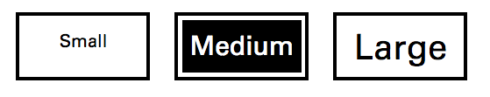
The large text size held up surprisingly well, without distorting the screen layout. It did force some of the pages to scroll and the prototype did not always handle this gracefully. The moderator showed participants how to scroll down when necessary.
All of the participants preferred the largest text setting, even if they could read the medium-sized text. Some opted for the medium-size text. None used the small text, although this size text had been used for the previous testing At least one participant wanted even larger text, but also felt that the screen itself was too small.

Michigan State University Mobile Interface Specification
MSU Usability/Accessibility Research and Consulting created and tested a user interface for accessible mobile voting systems based on prior research. The text size, spacing, and font face in the design specification and prototype were universally designed to meet the needs of individuals with low vision or dyslexia without customization.
The project used the National Association for the Visually Handicapped large print standard as the basis for selecting font sizes, converting them to equivalent sizes on the mobile screens. The size is determined by the length of the em-dash characters.
- A minimum of 16 typographic points (5.64mm) for normal text and 12.44 typographic points (4.39mm) for bold text
- A minimum line height of 1.25 ems (125% of the font size)
- All text should be mixed-case to ensure readability.
- A sans-serif font face should be used to ensure readability, especially for individuals with dyslexia and low vision.
- When possible, larger text should be used for headings and to make hierarchies and relationships more apparent visually.

Usability testing of a prototype based on the specification with individuals with dexterity impairments, low vision, dyslexia, and no impairments resulted in several design recommendations:
- Users from all groups found the large default text size (the equivalent of 16 typographic points) usable.
- Some users with low vision experienced difficulties with the smaller, bold text (the equivalent of 12.5 typographic points).
- Users from all groups want the ability to adjust text size on-the-fly (e.g., make text smaller or larger without leaving a page).

Maryland Voting System Comparison Testing
For the Maryland State Board of Elections, researchers from the University of Baltimore tested equipment from four manufacturers, with a total of 120 participants with a variety of accessibility needs.
The default text sizes were too small for many of the participants. The exceptions were those who used audio exclusively or who had perfect vision (that is, no deterioration due to age, and certainly no other issues that reduced visual acuity).

Los Angeles Voting Systems Assessment Project (VSAP)
The VSAP project includes both screen and printed ballot specifications, with a strong visual hierarchy.
Printed ballots (from draft print specs)
- Candidates: 11pts (3.9mm)
- Headings and titles: 13 - 15 pts (4.6 - 5.3mm)
- Secondary information: 9-10 pts (3.2 - 3.5mm)

The electronic interface has large text, with an option to make it larger. The screen is a 15.6” hinged display. The unofficial photos below show two screens and a photograph of how the screen sits in the kiosk.
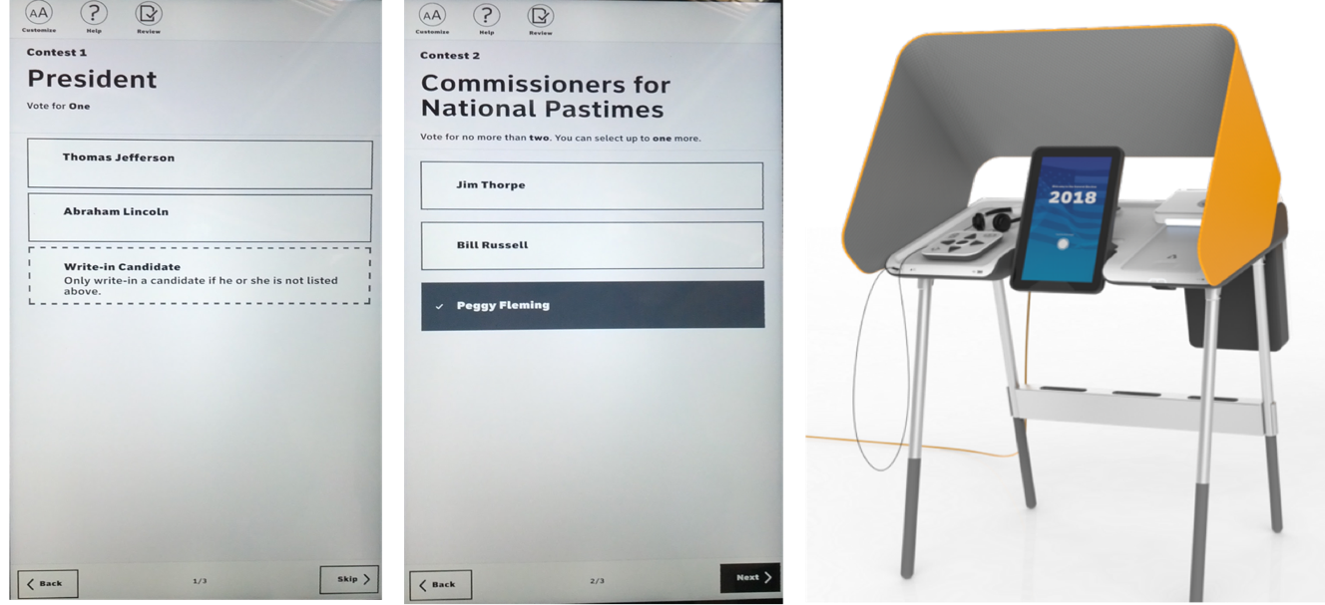
(1) Contest screen for President, nothing selected. (2) Contest screen for Commissioner for National Pastimes with one selected (3) Photo of the entire kiosk showing the size of the screen in context. NOTE: These screens were captured with a mobile phone camera during a demo in July 2016 and may not reflect the current project status. The photo of the kiosk is from lavote.net/vsap

Research and guidelines from general readability research

University of Baltimore
Research at the University of Baltimore has a focus on how people with low literacy read materials from a wide range of contexts.
Research with online texts in 2005 found that readers with low literacy skills need text that is
- 14 points (4.9mm) or larger
- large x-height
- relatively short line length (4-5 inches at most)
- clear chunking & text hierarchy.

What are the research gaps?
What size text can be used that is both acceptable to people with no visual disabilities and makes it possible for the largest number of people with visual disabilities to read it?
How can the VVSG set requirements for different devices, taking into account expectations for font sizes on smaller screens or fixed-size kiosk screens?
How do systems currently certified to the VVSG handle text sizes? What sizes (in mm) do they support? How does the screen adjust or scale when the text size is increased?

How text size is measured
Font sizes are typically defined in a measure called a typographical point, measured by the length of the em-dash character. Although software and web CSS stylesheets are also measured in “points],” this programmatic measurement is not the same as a typographic point. Programmatic points do not have a standard relationship to physical size.
A further complicating factor for thinking about the size of text is that the VVSG uses millimeters because this is a convention for standards. It is also a physical measure of the actual size of the text so can be matched to a typographical point:
1 typographical point is 1/72 (0.014) inch or 0.35278 mm
The table on the next pages shows a range of text sizes in typographical points and mm matched to the range of text sizes currently specified in the VVSG, along with a sample that shows relative size on the screen and actual size if printed.

(continued on next page)

Table of text sizes
Print this page to see the real size of these text samples.
All text is in Arial Regular at the point size listed in the third column
VVSG | MM | Points | Sample text
Small | 3.0 | 8.5 | Official Ballot - Vote for One
Small | 3.2 | 9 | Official Ballot - Vote for One
Small | 3.5 | 10 | Official Ballot - Vote for One
Small | 4.0 | 11.25 | Official Ballot - Vote for One
 | 4.2 | 12 | Official Ballot - Vote for One
 | 4.9 | 14 | Official Ballot - Vote for One
 | 5.6 | 16 | Official Ballot - Vote for One
Large | 6.3 | 17.75 | Official Ballot - Vote for One
Large | 7.1 | 20 | Official Ballot - Vote for One
Large | 8.5 | 24 | Official Ballot - Vote for One
Large | 9.0 | 25.5 | Official Ballot - Vote for One
 | 9.5 | 27 | Official Ballot - Vote for One

Full text of VVSG requirements
3.2.5 Visual display characteristics
The requirements of this section are designed to minimize perceptual difficulties for the voter. Some of these requirements are designed to assist voters with poor reading vision. These are voters who might have some difficulty in reading normal text, but are not typically classified as having a visual disability and thus might not be inclined to use the Acc-VS.
d. For all text intended for voters or poll workers, the voting system shall provide a font with the following characteristics i. Height of capital letters at least: 3.0 mm
ii. x-height of at least: 70% of cap height
iii. Stroke width at least: 0.35 mm.
e. A voting system that uses an electronic image display shall be capable of showing all information in at least two font sizes:
i. 3.0-4.0 mm cap height, with a corresponding x-height at least 70% of the cap height and a minimum stroke width of 0.35 mm;
ii. 6.3-9.0 mm cap height, with a corresponding x-height at least 70% of the cap height and a minimum stroke width of 0.7 mm; under control of the voter. The system shall allow the voter to adjust font size throughout the voting session while preserving the current votes.
Discussion: While larger font sizes may assist most voters with poor vision, certain disabilities such as tunnel vision are best addressed by smaller font sizes. Larger font sizes may also assist voters with cognitive disabilities. This requirement mandates the availability of at least two font sizes, but additional choices (including continuous variability) are allowed.
f. Text intended for the voter should be presented in a sans serif font.
Discussion: In general, sans serif fonts are easier to read on-screen, they look reasonably good when their size is reduced, and they tend to retain their visual appeal across different platforms.

3.3.2 Enhanced visual interfaces
This section has only 1 requirement (about synchronous audio and visual displays). The rest refers back to 3.2.5. That section is also cited in 3.3.7-Design in support of cognitive disabilities.

