Scrolling on a ballot
A white paper for the EAC-NIST Human Factors Public Working Group
Center for Civic Design - Whitney Quesenbery, Dana Chisnell
University of Baltimore - Kathryn Summers
Michigan State University UARC - Sarah J. Swierenga, Graham L. Pierce, Jennifer Ismirle
JSutton Media – Jennifer Sutton
Draft: November 29, 2016
This brief white paper looks at requirements in the VVSG for scrolling on a ballot, comparing the current VVSG requirements with more recent research evidence and making recommendations
Table of Contents
Principles this relates to 1
Current VVSG requirements 1
Why this requirement needs updating 1
What should the VVSG say? 2
Research evidence 3
From elections experience 3
Better Ballots 3
California 2016 Senate Primary 3
Maryland and the ExpressVote ballot marking device 3
From voting system design research 3
Trace Center 3
Anywhere Ballot 3
Travis County STAR-Vote 4
Los Angeles Voting Systems Assessment Project (VSAP) 4
Michigan State University Mobile Interface Specification 5
What are the research gaps? 5

Principles this relates to
Principle 3: Marked as intended
Ballots are presented in a clear, understandable way, and is operable by all voters.
3.2: Operable - Voters and poll workers must be able to use all controls accurately, and all ballot changes are made with the direct control of the voter.

Current VVSG requirements
3.2.4 Voter instructions, plain language, and information presentation
The features specified in this section are intended to minimize cognitive difficulties for voters. Voters should always be able to operate the voting system and understand the effect of their actions. Note that the “should” requirements in this section must be adhered to unless there is strong justification provided for making an exception.
e. The voting system shall provide the capability to design a ballot with a high level of clarity and comprehensibility.
i. The voting system should not visually present a single contest spread over two pages or two columns.
Discussion: Such a visual separation poses the risk that the voter may perceive one contest as two, or fail to see additional choices. If a contest has a large number of candidates, it may be infeasible to observe this guideline.

3.2.6 Voter-interface interaction
The requirements of this section are designed to minimize interaction difficulties for the voter.
a. The electronic ballot interface shall not require page scrolling by the voter.
Discussion: That is, the page of displayed information must fit completely within the physical screen presenting it. Scrolling is not an intuitive operation for those unfamiliar with the use of computers. Even those experienced with computers often do not notice a scroll bar and miss information at the bottom of the "page." Voting systems may require voters to move to the next or previous "page."

Why this requirement needs updating
This requirement was based on the difficulty many voters with low digital literacy or some disabilities have using a scroll bar. This is still an issue that the VVSG needs to consider.
Changes in technology that relate to this requirement include:
- Current versions of the two major platforms -- Windows and MacOS -- use different logic for the scrolling interaction, so that there is no common convention to draw on, and even an experienced computer user might be confused.
- Touch screen mobile devices and tablets use tapping and other gestures that are more common and expected, even by people who may not use a touch device regularly.
- Users may be more familiar with a mouse “scroll wheel” instead of on-screen controls.

In addition, we now have research data from EAC/NIST-funded projects that supply interaction models for in-page scrolling that work for people with low or no digital literacy.
Ballots often contain contests that cannot fit on a single screen, because:
- The list of candidates is long
- The ballot question text is long
- The voter has increased the text size
- The voting system has a small screen
- The voter is using a device with a small screen for remote ballot marking

The current requirement envisions that these contests will have multiple “pages,” allowing voters to navigate through these pages to vote. This sounds reasonable, but leads to problems in practice. For example:
- It is harder for voters to easily scan through the list of candidates when there is more than one page.
- Using separate pages adds navigational complexity and reliance on voters understanding the boundaries of the contest
- Voting systems may have problems managing voter’s choices and voting rules for over- and under-voting when a list of candidates spans more than one page.

What should the VVSG say?
The VVSG should include a core requirement that:
- All of the information and voter choices in a contest appears on a single page, although displaying the voter choices may require navigation within that page if the page spans several “screens”.
- Navigation options include strong cues to support voters, including cues that the area scrolls.
On an electronic ballot interface this would require a scrolling action that does not rely on scroll bars, so that voters can use a combination of directly perceivable controls or gestures to read all of the names in a contest or text in a measure.
- Navigation within the contest does not rely on conventional platform scroll bars.
- Navigation within the contest does not rely on knowledge of any particular computer platform or interface standard.
- The header and footer of the screen is fixed and does not scroll or disappear, so voters do not lose orientation or context.
- Controls have visible labels that include words as well as symbols.
- Optionally, controls appear only when the contest requires scrolling, so they do not clutter the screen, and appear in a consistent location both visually and non-visually.
- Controls can be activated by voice, or any assistive technology.
- Requirements for the size of touch areas apply to any navigation controls.
Cues that an area of the screen is a scrolling region might include:
- The visible presence of navigation controls
- Breaking the elements or rows of text at the top and bottom of the screen in the middle, or making them appear to fade, or other visual techniques to suggest that more information is available.
- An indicator showing the relative position of the current view within the full scrolling area.
On paper ballots, the ballot authoring system and voting system should
- Be able to present an entire contest in a single column or on a single page. For example, the ballot paper should be large enough to accommodate contests with many candidates.
- Support a visual presentation that creates clear boundaries for each contest, including contests that span multiple columns.

Research evidence

From elections experience

Better Ballots
Two reports from the Brennan Center, Better Ballots (2008) and Better Design: Better Elections (2012) looked at evidence of problems in real election results. Both reports include evidence that splitting a contest on a paper ballot into two columns causes overvotes.
- A contest split across 2 columns in Ohio in 2008 created a statistically significant increase in errors. A similar layout in Kewaunee, Wisconsin, 2002 produced a 10.7% difference in overvotes from the rest of the state.
- A contest split into two rows in New York City in 2012 produced 114% more lost votes than a similar column on a single row

California 2016 Senate Primary
In the June 2016 primary, there were 34 candidates for Senate. Although analysis is still in progress, an early look at the results suggests that the number of overvotes was higher than normal in all counties, and that counties where the contest spanned multiple columns on paper ballots had very high overvote rates.

Maryland and the ExpressVote ballot marking device
The ExpressVote interface as implemented in Maryland allows up to 7 candidates per page. In early testing of the system, Maryland discovered flaws in how the system managed navigation across multiple pages in a Vote-for-n contests. The problem resulted in their using paper ballots for all voting, including early voting centers.

From voting system design research

Trace Center
The Trace Center produced an early tablet-based voting system prototype suggesting a way to avoid scroll bars while allowing a page to scroll. This interface had on-screen buttons to allow voters to display more text that appeared at the bottom and top of the list when needed. A supporting visual cue was that text was cut off in the middle of the line rather than breaking evenly between lines or items in the list.

Anywhere Ballot
The Anywhere Ballot prototype followed the lead from the Trace Center with a ballot designed for an iPad or other tablet. As a prototype, the implementation has some limitations.
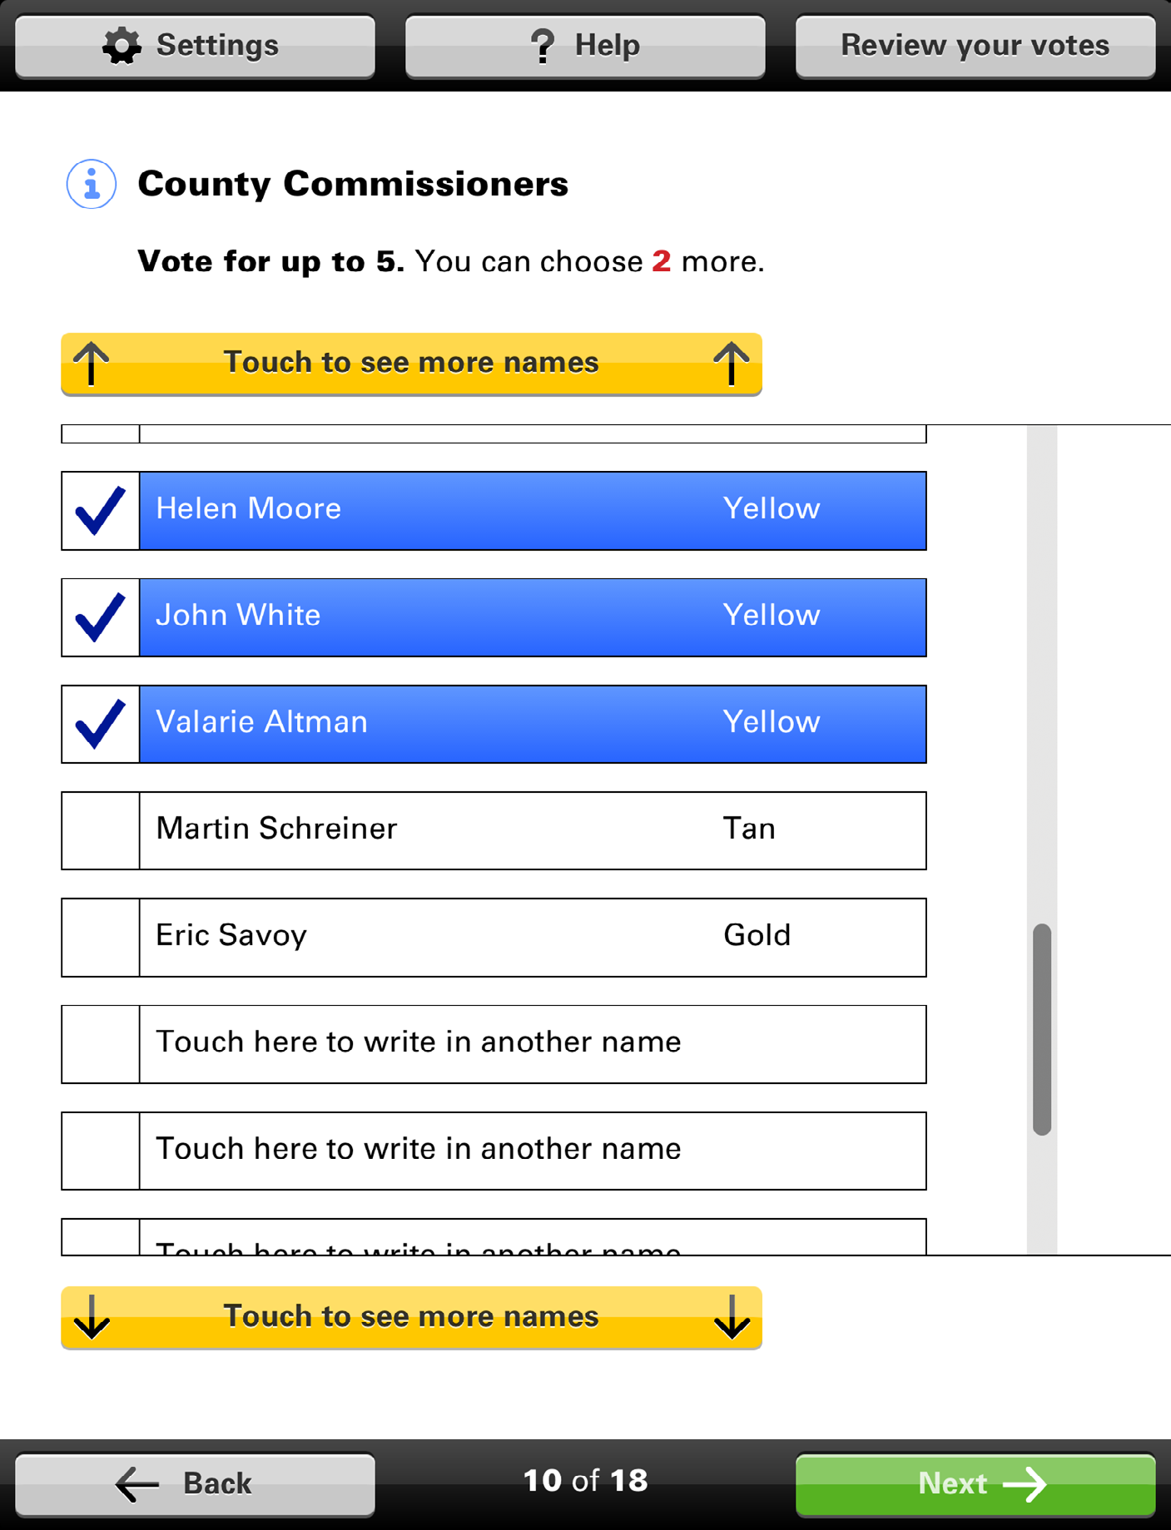
The Anywhere Ballot with buttons
to show more candidates visible at
the top and bottom of the list.
The interface includes:
- Scroll up and scroll down buttons that appear only when the list or text is longer than the area defined on the screen. In the default presentation, they are yellow and active when needed, greyed out when at the top or bottom of the list or page.
- The header and footer of the screen are fixed, so only the list of candidate or ballot question full text scrolls.
- Standard scrolling gestures for the platform such as swiping up or down work.
- There is a scroll bar indicator on the right side of the screen that allows the voter to gauge their position within the longer list or text. This indicator is also a functional scroll bar, with the direction of travel matching the platform conventions.
- When the text or list is larger than the display window, it is cut off in the vertical center of a line or list box, so only the top of the letters are visible.

Travis County STAR-Vote
The current Request for Information (RFI) outlining the requirements for STAR-Vote follows the Anywhere Ballot with modifications, including:
- 9.3.1.10.6 - No scroll bars should be present on any screens
- 9.3.1.10.3 - The review screen must paginate, rather than scroll to display more than one page of content
- 9.3.1.10.7 - When reaching the bottom of the list on the review screen, the “touch to see more” button should be greyed out and disabled, rather than removed

Los Angeles Voting Systems Assessment Project (VSAP)
The Los Angeles voting system prototype (as of June, 2016) followed the Trace and Anywhere Ballot approach. The final prototype in June, 2016, did not have any contests that required scrolling, but earlier versions used a small round button that appeared at the top and bottom of the list. The lines that span the boundary of the scrolling area are both cut off in the middle and have a graduated fading.

Michigan State University Mobile Interface Specification
MSU Usability/Accessibility Research and Consulting created and tested a user interface for accessible mobile voting systems based on prior research.
The design specification and prototype include an oversized scroll bar and up/down buttons with large active regions (e.g., touchable areas of at least 20mm), optimized for individuals with dexterity and visual impairments. All interaction is available through a single tap, with the exception of a drag option for the scroll slider. Gestures such as flick-to-scroll/swiping were not included due to concerns over increased errors for those with physical impairments (e.g., tremors) or who are unfamiliar with touch screens. The page header (which identifies the contest and indicates whether selections have been made) and footer (which includes navigation buttons to move to the previous and next contest, review screen, and help) are static, and fixed in place on the screen.
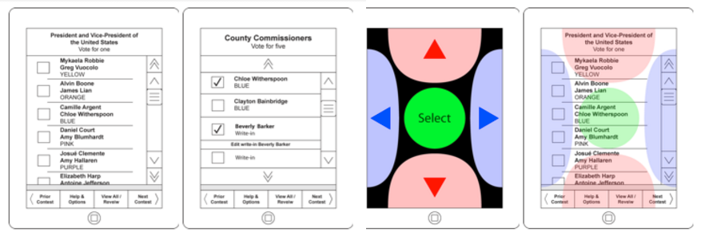
4 screens from the MSU prototype (1) Contests page in Normal mode, (2) Contests page in Hybrid Screen Reader mode, (3) Contests page in Audio-Only Screen Reader mode, (4) Contests page in Five Button Overlay mode

The specification also includes a screen reader mode, where scroll bars are replaced with large buttons at the top and bottom of lists, and two novel Five-Button Modes: An Overlay Mode keeps the visual display unchanged, while providing significantly larger buttons to control scrolling and interaction, and an Audio-Only Screen Reader Mode provides screen privacy and on-screen controls for those without touch screen experience.

What are the research gaps?
- What is a reasonable number of candidates to require that a voting system handle gracefully, given the emerging propensity for election rules that encourage large candidate pools?
- Are there particular designs and labels for a “read more” button that work better for voters?
- Are there gesture conventions that are consistent and well known enough that they can be incorporated into a voting system as an alternative way to navigate within a contest, for example, using up/down for navigating within a page and left/right for between pages, much as the 5-button interface uses the top/bottom and left/right buttons?

