Contrast requirements
A white paper for the EAC-NIST Human Factors Public Working Group
Center for Civic Design - Whitney Quesenbery
Michigan State University UARC - Sarah J. Swierenga, Graham L. Pierce, Jennifer Ismirle
Draft: December 11, 2016
This brief white paper looks at requirements in the VVSG for contrast of text and other information for voters, comparing the current VVSG requirements with more recent research evidence and making recommendations for how the VVSG might be updated.

Table of Contents
Principles this relates to 2
Current VVSG requirements 2
Why these requirements need updating 3
What should the VVSG say? 3
Research evidence 4
From vision research 4
TAdER – Text Adaptability is Essential for Reading 4
From voting system research 4
Anywhere Ballot 4
Michigan State University Mobile Interface Specification 5
Los Angeles VSAP 5
What are the research gaps? 5
Appendix: Color contrast ratios 6
Sample contrasts for text on white and grey-scale backgrounds 6
Sample high contrast black on white background colors 6
Sample high contrast text colors on a black background 7
Sample low contrast combinations 7

Principles this relates to
Principle 3: Marked as intended
Ballots are presented in a clear, understandable way, and is operable by all voters.
3.1: Perceivable - The default system settings for displaying the ballot work for the widest range of voters, and voters can adjust settings and preferences to meet their needs.
3.2: Operable - Voters and poll workers must be able to use all controls accurately, and all ballot changes are made with the direct control of the voter.
Principle 5: Meets Web accessibility standards
Browser-based systems meet web accessibility standards in addition to voting standards.
5.1: When a voting system uses standard web software platforms (HTML or native apps), the voting system meets all requirements in WCAG 2.0 Level AA any applicable requirements in the VVSG. The relevant success criteria is 1.4.3, but VVSG 1.1 requires more contrast than WCAG.
Criteria | Level | Text contrast | Large text contrast
1.4.3 | AA | 4.5:1 | 3:1
1.4.6 | AAA | 7:1 | 4.5:1

Current VVSG requirements
3.2.5 Visual display characteristics
The requirements of this section are designed to minimize perceptual difficulties for the voter.
h. The colors in the default presentation shall support perception by voters and poll workers with color vision deficiencies, of all text, controls, and infographics or icons on the ballot or ballot interface.
i. The default visual display for voters and poll workers of a voting station with an electronic display shall have a luminosity contrast ratio between the foreground text and background color of at least 10:1 for all elements that visually convey information such as text, controls, and infographics or icons. For paper ballots, the contrast ratio shall be at least 10:1 as measured based on ambient lighting of at least 300 lx.
Discussion: A 10:1 luminosity contrast ratio provides enough difference between the text and background to enable people with most color vision deficiencies to read the ballot. Note that this is higher than the general web requirements of 4.5:1 in WCAG 2.0 Checkpoint 1.4.6 (Level AAA) to accommodate a wider range of visual disabilities.
ii. A voting station with an electronic display screen shall have a high contrast mode either as an initial setting or under the control of the voter. If the system allows the voter to adjust contrast during the voting session it shall preserve the current votes. High contrast is a luminosity contrast ratio between the foreground text and background color of at least 20:1. The high contrast mode shall use at least one of the following color combinations:
- Black text on a white background
- White text on a black background
- Yellow text on a black background
- Light cyan text on a black background
Discussion: A high contrast mode ensures that there is an option for the visual presentation for people with color vision deficiencies or whose vision requires high contrast.

Why these requirements need updating
The current contrast requirements set a good base for a universal design that meets the visual needs of many voters without accessibility adjustments.
The current VVSG requirement for a minimum 10:1 contrast ratio (a higher contrast than required in WCAG 2.0) for information in text, buttons, icons, or other controls is appropriate in the context of use of a voting system, increasing readability for most voters.
- Polling places are often poorly lit, so setting a high contrast increases the ability of most voters to read the screen or paper.
- Voting systems usually have limited options for adjustment of either the physical device or the screen display.
- Voting is a relatively rapid task, so voters have little time to use complex preferences.
However, there are also voters who need lower contrast, including people with dyslexia, people with some low vision conditions, or those who are sensitive to bright colors like light backgrounds.
- Require two high contrast options, one with a light background and one with a dark background.
- Add a requirement for at least one low-contrast setting.
- Adjust the contrast ratio requirement to be technically possible, as some of the specified colors (notably light cyan) cannot be met at a 20:1 ratio
- Make the color choices more explicit with guidance that includes a range of color specifications.

What should the VVSG say?
The requirement in 3.2.5.h.ii should be expanded to include two high contrast options and one low contrast option, in addition to a standard contrast option used as a default. The high contrast options should specify an appropriate contrast ratio for the color family, because not all colors can meet the current 20:1 requirements
The settings should include the three following options, in addition to the default colors chosen by the system designer.

1. An option for high contrast on a white background
- Black text on a white background, with a contrast ratio of at least 20:1
2. An option for high contrast on a black background
At least one of the following combinations on a black background in the range of #000000 to #111111
- Yellow text similar to #FFFF00, with a contrast ratio of at least 17.5:1
- Cyan text similar to #00FFFF with a contrast ratio of at least 15:1
- White text similar to #FAFAFA with a contrast ratio of at least 18:1
3. A low contrast option
At least one of the following combinations for low contrast, all with a with a contrast ratio in the range of 4.5:1 to 8:1
- Brown text similar to #BB9966 on a black background (7.8:1)
- Black text on a background with text similar to #BB9966 (7.8:1)
- Grey text similar to #6C6C6C on a white background (5.2:1)
- Grey/brown text similar to #97967E on a black background (6.9:1)
- Grey text similar to #888888 on a dark background similar to #222222

Research evidence

From vision research

TAdER – Text Adaptability is Essential for Reading
This website by Shawn Lawton Henry summarizes the needs for text adaptation for low vision. The page identifies examples of color combinations for both high and low contrast. The page lists three different challenges:
- Not enough contrast for readability for many people
- High contrast because of loss of contrast sensitivity
- Needing low luminance because bright colors are not readable
Most of the low contrast color combinations suggested for the VVSG are taken from this paper.

From voting system research

Anywhere Ballot
The Anywhere Ballot included a screen for text size and contrast settings. Based on consultations with experts on low vision, there are four options: full color, black on white, yellow on black, and a sepia low contrast combination (from the TAdER site).
This interface was tested with voters with low literacy and a variety of low vision disabilities, but were not selected specifically for contrast needs. These users preferred high contrast black and white combinations to any of the color variations, but tried all of them as they explored the options presented to them in the interface.

Michigan State University Mobile Interface Specification
MSU Usability/Accessibility Research and Consulting created and tested a user interface for accessible mobile voting systems based on prior research. The interface specification calls for a default contrast ratio of at least 7:1, a high contrast option of at least 19.5:1, and a low contrast option between 4:1 and 4.9:1.
It also specifies that high contrast should use a bright color palette (such as yellow on black), with few colors used, and that low contrast be monochromatic (e.g., greyscale) and should avoid black or white. Additionally, the specification calls for solid backgrounds (no gradients or pictures) behind text and buttons.
In usability testing of a voting prototype with black text on a white background, some individuals with low vision indicated that they would prefer the ability to switch to light text on a dark background.

Los Angeles VSAP
This project opted for an interface that was entirely high contrast (mostly black-on-white) as an aesthetic choice that also offered good contrast for most uses.
The opening “attract screen” (the screen displayed when no voting session is active) has very large white text on a blue background with sufficient contrast.
Earlier versions of the prototype had some screens with white text on a black background, but switching between a light and dark background adds stress to any voter whose vision requires one or the other.

What are the research gaps?
Accessibility needs for low vision are complex and varied, often requiring very individualized settings, identified through trial and error. There has been little work applied to contexts like voting systems in which people interact with a shared system for very short periods of time.
There has not been any large-scale testing to see whether the recommendations of a limited and basic set of contrast settings will meet the needs of a sufficiently large number of voters with visual disabilities to be considered to be a universal design solution.

Appendix: Color contrast ratios
The color contrast requirements, in WCAG 2.0 are luminosity contrast ratios between the foreground text and background color of the text, icons, or shapes used to communicate information while voting.
The ratio ranges from 1:1 (no difference in contrast) to 21:1 (black and white).
The VVSG uses the same measure to set requirements for voting systems. One advantage of this measure is that there are many free tools available to perform the calculations.
In the display samples below, colors are identified by their hexadecimal values, commonly used in web interfaces.

Sample contrasts for text on white and grey-scale backgrounds
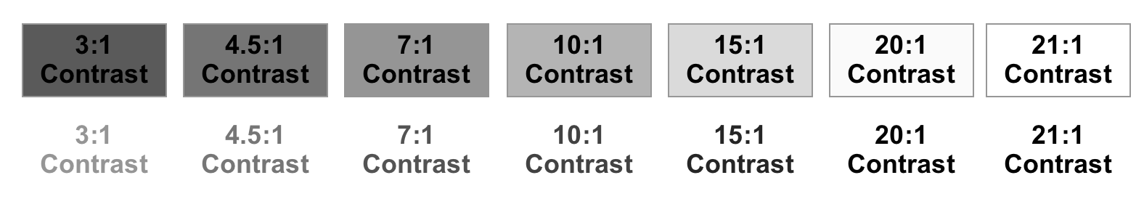
Contrast ratio | 3:1 | 4.5:1 | 7:1 | 10:1 | 15:1 | 20:1 | 21:1
Background colors with black text | #5a5a5a | #767676 | #959595 | #b4b4b4 | #dadada | #fafafa | #ffffff  (white)
Text on white background | #949494 | #767676 | #535353 | #424242 | #262626 | #060606 | #00000  (black)

Sample high contrast black on white background colors
Contrast ratio | 20.26:1 | 20.62:1 | 20.87:1 | 21:1
Text color | #060606 | #030303 | #010101 | #00000

Sample high contrast text colors on a black background
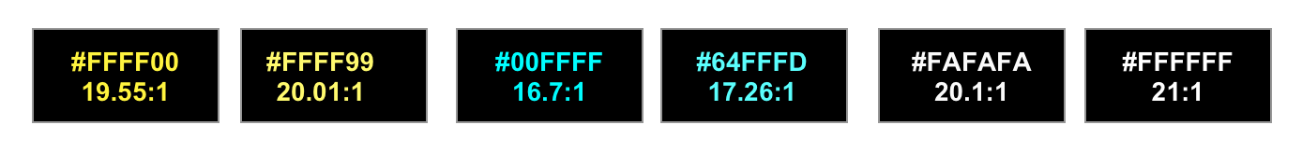
Contrast ratio | 19.55:1 | 20.1:1 | 16.7:1 | 17.26:1 | 20.1:1 | 21:1
Color family | Yellow | Yellow | Cyan | Cyan | White | White
Text colors | #ffff00 | #ffff99 | #00FFFF | #64FFFD | #fafafa | #ffffff

Sample low contrast combinations
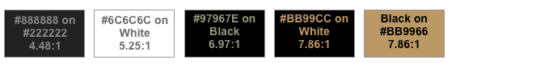
Contrast ratio | 4.48:1 | 5.25:1 | 6.97:1 | 7.86:1 | 7.86:1
Color family | Grey | Grey | Grey | Sepia | Sepia
Text colors | #888888 | #6c6c6c | #ffffaa | #bb99cc | #000000
Background | #222222 | #FFFFFF | #000000 | #000000 | #bb9966

Color source: TAdER — Text Adaptability is Essential for Reading. http://www.tader.info/display.html

