This is page 1, section 1

I’ve made the text really big, so that you can see it easily if you make the page view small. It’s easier to see what happens if you are in a view that shows multiple pages at once.

I’ve used A5 paper in the layout for the same reason.

Go to page 5 for the explanation of the problem and how to fix it.

On page 4, you’ll also see how “link to previous header” works and what you have to do to be able to change the header.

This is page 2 section 1

This is page 3, section 1

This is page 4, section 1

When you add a new section, it looks like the header doesn’t change. That’s because the default setting is to keep it the same as the previous section.

To see this working, go to the last page and add lines until it makes a new page. It will have the same header as on this page. Edit the header, and you will see

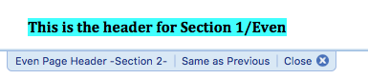

To edit the header in the new section, without also changing the previous section, uncheck “Link to Previous” in the Header/Footer dialog

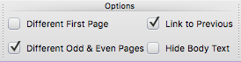

This is page 5, the first page of section 2

If you just delete this page, including the new section/page marker, the header for this page becomes the section 1 header for odd pages and the even pages headers are blank.

That’s because, according to Microsoft:

“Each section break controls the layout and formatting of the section previous to the break. For example, if you delete a section break, the text previous to the break acquires all the formatting of the section that follows the break.”

Here’s the work-around:

Change the kind of section break.
1. Click in the section you want to change.
2. Format Menu > Document > Layout tab
3. On Section Start popup, change from New page to Continuous

Now you can delete any text and the blank page will be gone.

